**Cricket management System**

**Cricket management System**

**A Project Report**

Submitted in partial fulfillment of the

Requirements for the award of the Degree of

**BACHELOR OF SCIENCE (INFORMATION TECHNOLOGY)**

**By**

**Mr. Avadhut Dilip Varvatkar**

**Seat Number: 2143551**

**&**

**Mr. Sujit Prabhakar Panda**

**Seat Number: 2143532**

**Under the esteemed guidance of**

**Mrs. Omkar Kulkarni**

**Professor**



**DEPARTMENT OF INFORMATION TECHNOLOGY**

**Seva Sadan’s**

**R.K. TALREJA COLLEGE**

***(Affiliated to University of Mumbai)***

**ULHASNAGAR- 421003**

**MAHARASHTRA**

**YEAR 2021-2022**

**SEVA SADAN’S**

**R.K. TALREJA COLLEGE**

***(Affiliated to University of Mumbai)***

**ULHASNAGAR- 421003**

**MAHARASHTRA**

**DEPARTMENT OF INFORMATION TECHNOLOGY**



**CERTIFICATE**

This is to certify that the project entitled, **“Cricket Management System”,** is benefited work of **“Avadhut .D. Varvatkar”** & **“Sujit. Prabhakar. Panda”** bearing Seat No: (**2143551** & **2143532)** submitted in partial fulfillment of the requirements for the award of degree of BACHELOR OF SCIENCE in INFORMATION TECHNOLOGY from University of Mumbai.

**Internal Guide Coordinator**

**External Examiner**

**Date: College Seal**

**ABSTRACT**

Cricket Management Software is a software application maintains the records related so cricket sport players. It is also take care of money transaction at the organization. It includes money collection to the organization by different sources. This application can be used by the organization to manage cricket sport data effectively. This system developed will reduce the manual work and avoid redundant data. By maintaining the player attendance fees and tour manually, then efficient reports cannot be generated. The system can generate efficient weekly, consolidate report based on the attendance. As the fees, attendance, tour and player details are maintain is registers it has been a tough task for admin and staff to maintain for long time. Instead, the software can keep long and retrieve the information when needed.

**ACKNOWLEDGEMENT**

We are pleased to present our project **“Cricket Management System”** and takes this opportunity to express our profound gratitude to all those people who helped us in completion of this project.

We thank our college for providing us with excellent facilities that helped us to complete and present this project. We should also like to thank the staff members and lab assistants for permitting us to use computers in the lab as and when requires.

I am equally grateful to my project guide **Mr. Omkar Kulkarni**

, who gave me moral support and guided me in different matters and solution regarding the topic.

I feel immensely proud in extending our heartiest thanks to **Prof. Leena Chawla** HOD of BSc.IT in Seva Sadan’s R.K. Talreja College for providing platform to improve my skills.

We express our deepest gratitude towards our project Guide **Mr. Omkar kulkarni**, for her valuable and timely advice during the various phases in our project. We would also like to thank her for providing us with all the proper facilities and support as the project coordinator. We would like to thank her for Support, patience and faith in our capabilities and for giving us flexibility in terms of working and reporting schedules.

Finally, we would like to thank everyone who has helped us directly or indirectly in our project.

**PREFACE**

Development of this application is highly economically feasible. The only thing to be done is making an environment with an effective supervision.

It is cost effective in the sense that has eliminated the paper work completely. The system is also time effective because the calculations are automated which are made at the end of the month or as per the user requirement.

This system developed will reduce the manual work and avoid redundant data. By maintaining the player attendance fees and tour manually, then efficient reports cannot be generated. The system can generate efficient weekly, consolidate report based on the attendance. As the fees, attendance, tour and player details are maintain is registers it has been a tough task for admin and staff to maintain for long time. Instead, the software can keep long and retrieve the information when needed.

**TABLE OF CONTENTS**

**Chapter 1: INTRODUCTION**

* 1. Background
  2. Objectives
  3. Purpose, Scope, and Applicability
     1. Purpose
     2. Scope
     3. Applicability
  4. Achievements
  5. Organization of Report

**Chapter 2: SURVEY OF TECHNOLOGIES**

**Chapter 3: REQUIREMENTS AND ANALYSIS**

* 1. Problem definition
  2. Requirements Specification
  3. planning and scheduling
  4. Software and Hardware Requirements
  5. Preliminary Product Description
  6. conceptual Models

**Chapter 4: SYSTEM DESIGN**

* 1. Basic Modules
  2. Data Design
     1. Schema Design
     2. Data integrity and constraints
  3. Procedural Design
     1. Logic Diagrams
     2. Data Structures
     3. Algorithms Design
     4. User interface design
     5. Security Issues
     6. Test Cases Design

**CHAPTER 5: IMPLEMENTATION AND TESTING**

5.1 Implementation Approaches

5.2 Coding Details and Code Efficiency

5.2.1 Code Efficiency

5.3 Testing Approach

5.3.1 Unit Testing

5.3.2 Integrated Testing

5.3.3 Beta Testing

5.4 Modifications and Improvements

5.5 Test Cases

**CHAPTER 6: RESULTS AND DISCUSSION**

6.1 Test Reports

6.2 User Documentation

**CHAPTER 7: CONCLUSIONS**

7.1 Conclusion

7.1.1 Significance of the System

7.2 Limitations of the System

7.3 Future Scope of the Project

REFERENCES

**Chapter 1**

**INTRODUCTION**

**INTRODUCTION:**

**Background:**

In brief, **project management objectives** are the successful development of the project’s procedures of initiation, planning, execution, regulation and closure as well as the guidance of the project team’s operations towards achieving all the agreed upon goals within the set scope, time, quality and budget standards.

**Objectives**:

The main objective of the application is to automate the existing system of manually maintain the records of all transactions.

**Purpose**:

Cricket Management Software is a software application maintains the records related so cricket sport players. It is also take care of money transaction at the organization. It includes money collection to the organization by different sources.

**Scope**:

This application can be used by the organization to manage cricket sport data effectively.

**Organization of Report**

References:

The Overall Description:

In this system we tried to make an encouragement to players who are interested.

We developers give our best.

Product perspective:

Product functions:

Types of accessing modules eg: administrator login

User characteristic:

For ex. We make this software like a history the more you go deeper you got more mysteries.

**Chapter 2**

**SURVEY OF TECHNOLOGY**

**SURVEY OF TECHNOLOGY**

A study of resource availability that may affect the ability to achieve an acceptable system. This evaluation determines whether the technology needed for the proposed system is available or not.

Can the work for the project be done with current equipment existing software technology & available personal?

Can the system be upgraded if developed?

If new technology is needed then what can be developed?

This is concerned with specifying equipment and software that will successfully satisfy the user requirement. The technical needs of the system may include:

**Front-end and back-end selection**

An important issue for the development of a project is the selection of suitable front-end and back-end. When we decided to develop the project, we went through an extensive study to determine the most suitable platform that suits the needs of the organization as well as helps in development of the project.

The aspects of our study included the following factors.

**Front-End selection**

1. It must have a graphical user interface that assists employees that are not from IT background.
2. Scalability and extensibility.
3. Flexibility.
4. Robustness.
5. According to the organization requirement and the culture.
6. Must provide excellent reporting features with good printing support.
7. Platform independent.
8. Easy to debug and maintain.
9. Event driven programming facility.
10. Front end must support some popular back end like Mysql Access.

According to the above stated features we selected **HTML CSS AND JAVASCRIT** as the front-end for developing our project.

**Back-End Selection**

* Multiple user support.
* Efficient data handling.
* Provide inherent features for security.
* Efficient data retrieval and maintenance.
* Stored procedures.
* Popularity.
* Operating System compatible.
* Easy to install.
* Various drivers must be available.
* Easy to implant with the Front-end.

According to above stated features we selected **MY SQL** as the backend.

The technical feasibility is frequently the most difficult area encountered at this stage. It is essential that the process of analysis and definition be conducted in parallel with an assessment to technical feasibility. It centers on the existing computer system (hardware, software etc.) and to what extent it can support the proposed system.

**Windows comments CMD:**

In Windows operating systems, the Command Prompt is a program that emulates the input field in a text-based user interface screen with the Windows Graphical User Interface (GUI).

It can be used to execute entered commands and perform advanced administrative functions. It can also be used to troubleshoot and solve certain kinds of Windows issues.

**Html:**

The most important use of HTML is accessibility, which is often neglected.

Semantic tags gives meaning to your page, if properly used.

It makes easier for people with disability, to access your content with assistive devices and screen readers.

This will include your ability to design and implement a responsive site that utilizes tools to create a site that is accessible to a wide audience, including those with visual, audial, physical, and cognitive impairments.

**CSS**:

CSS is used for defining the styles for web pages. It describes the look and formatting of a document which is written in a markup language. It provides an additional feature to HTML. It is generally used with HTML to change the style of web pages and user interfaces.

**JavaScript:**

JavaScript is a text-based programming language used both on the client-side and server-side that allows you to make web pages interactive. Where HTML and CSS are languages that give structure and style to web pages, JavaScript gives web pages interactive elements that engage a user. Common examples of JavaScript that you might use every day include the search box on Amazon, a news recap video embedded on The New York Times, or refreshing your Twitter feed.

Incorporating JavaScript improves the user experience of the web page by converting it from a static page into an interactive one. To recap, JavaScript adds **behavior** to web pages.

**MySQL:**

MySQL, is an open source relational database management system. It is based on the structure query language (SQL), which is used for adding, removing, and modifying information in the database. Standard SQL commands, such as ADD, DROP, INSERT, and UPDATE can be used with MySQL. MySQL can be used for a variety of applications, but is most commonly found on Web servers. A website that uses MySQL may include Web pages that access information from a database.

**PHP:**

PHP is an open-source server-side scripting language. It's used to make web apps, as well as dynamic and static websites. PHP is the most well-known scripting language among server-side scripting languages. Web developers also use PHP to improve websites and website pages. Today, it occupies 82 percent of the internet. HTML is used to create web pages, and HTML is used to execute code on the user's browser. PHP, on the other hand, is a server-side scripting language that runs before the user's browser. It is well suited to the design of e-commerce applications, interactive websites, and web application growth.

**Chapter 3**

**REQURIEMENTS AND ANALYSIS**

**3.1 Problem Definition**

**PROBLEM DEFINITIONS**

This system developed will reduce the manual work and avoid redundant data. By maintaining the player attendance fees and tour manually, then efficient reports cannot be generated. The system can generate efficient weekly, consolidate report based on the attendance. As the fees, attendance, tour and player details are maintain is registers it has been a tough task for admin and staff to maintain for long time. Instead, the software can keep long and retrieve the information when needed.

3.2 Requirements Specification

3.3 Planning and Scheduling

Software Project planning

The Cricket management system planning the project planning must incorporate the major issues like size & cost estimation scheduling, project monitoring, personnel selection evaluation & risk management. To plan a successful software project, we must understand.

* Scope of works to be completed
* The Risk Analysis
* The Cost to be Expended
* The resources required mandatory
* The Schedule to be followed

**Future scope**

Development of this application is highly economically feasible. The only thing to be done is making an environment with an effective supervision.

It is cost effective in the sense that has eliminated the paper work completely. The system is also time effective because the calculations are automated which are made at the end of the month or as per the user requirement.

**The Risk Analysis**

scope

Time

Cost

Quality risk

Quantitative risk

**Plan risk management**

Analysis and decision making to impact risk management

Stockholder will be involved in planning risk

**Schedule risk**

In cricket project management they are total two member of team and we conduct the meeting on Sunday to Sunday. Schedule risk is the likelihood of failing to meet schedule plans and the effect of failure. The duration of learning skills will be increases. Assigning the wrong resources for projects. Failed to get approval for the project and failure to baseline schedules.

**Cost risk**

We used all free tools for over projects like VS code, Microsoft word, local host, and etc.

**Quality risk**

The potential that products and services will not be fit for purpose.

**Scope risk**

Individuals may add features to the product that were not approved. The project team may not identify all the deliverables, requiring changes later.

**Resource risk**

A resource risk is the chance that you will fail to meet a goal due to a lack of resources. Resources can include financing, time, skilled workers and anything else you need to achieve a particular goal.

**Customer satisfaction risk**

**3.4 Software and Hardware Requirements**

1. **Hardware Requirements**

Processor: Intel Core Duo 2.0 GHz or More

RAM: 1GB or More

Hard disk: 80GB or More

1. **Software Requirements**

Front End: JavaScript, Html and CSS.

Back End: PHP and MySQL.

Operating System: Windows XP, 7, 8 and 10.

**Functional Requirements**

The Cricket Management System involves the following function.

Easily track player, fees attendance and tour information.

Quickly produce attendance bulletin.

Easily add and remove fees details of player.

Maintain fees details of players

Easily to manage player details

Provide player information

3.5 **Preliminary Product Description**

**INTRODUTIONS:**

A System analyst is an individual who is in charge of designing, modifying, or analyzing various system. System analyst can work on their own or they can work as part of a large team help keep technical system run smoothly. The role of system analyst includes system analysis and design.

This is the understanding and specifying in detail what an information should do for a particular customer/organization. The system analyst will need to have a detailed study of how the current system works. The various tasks in the system analysis include the following.

Understanding application.

Planning.

Scheduling.

Developing candidate solution.

Performing trade studies.

Recommending alternative solution.

Supervising, installing and maintaining the system.

This system manages to the analysis of the creation and develops manual entry of the player information like profile fees attendance and tour. The main aim of Cricket Management is to manage the details of Cricket, Players, Attendance, fees. It manages all the information about Cricket, Fees, tour. The project is totally built at administrative end and thus only the administrator is guaranteed the access. The purpose of the project is to build an application program to reduce the manual work for managing the Cricket, Fees, Players, attendances and fees. It tracks all the details about the Players, Attendance, fees and tour.

**EXISTING SYSTEM**

Existing system is a manual entry for the player. Here the attendance and fees will be carried out in the hand written registers. It will be a tedious job to maintain the record for the user. The human effort is more here. The retrieval of the information is not as easy as the records are maintained in the hand written registers.

This application requires correct feed on input into the respective field. Suppose the wrong inputs are entered, the application resist to work. So, the user finds it difficult to use.

**PROPOSED SYSTEM**

The overcome the drawbacks of the existing system the proposed system has been evolved. This project aims to reduce the paper work and saving time to generate accurate results from the players, attendance, fees and tour. The provide with the best user interface.

**ADVANTAGE OF PROPOSED SYSTEM**

It is trouble-free to use.

It is relatively fast approach to enter information in highly reliable, approximate result from user best user Interface and efficient reports.

**FEASIBILITY STUDY**

Feasibility analysis begins once the goals are defined. It starts by generating broad possible solution, which are possible to give an indication of what the new system should look line. This is where creativity and imagination are used. Analysts must think up new ways of doing things – generate new ideas. There is no need to go into the detailed system operation yet. The solution should provide enough information to make reasonable estimates about project cost and give users an indication of how the new system will fit into organization. It is important not to exert considerable change the original goal. Feasibility of new system means ensuring that the new system, which we are going to implement, is efficient and affordable. There are various types of feasibility to be determined. They are-

**ECONOMICALLY FEASIBILITY**

Development of this application is highly economically feasible. The only thing to be done is making an environment with an effective supervision.

It is cost effective in the sense that has eliminated the paper work completely. The system is also time effective because the calculations are automated which are made at the end of the month or as per the user requirement.

**TECHNICAL FEASIBILITY**

The technical requirement for the system is economic and it does not use any other additional Hardware and software. Technical evaluation must also assess whether the existing system can be upgraded to use. The new technology and whether the organization have the expertise to use it. Install all upgrades framework into the package supported windows-based application. This application depends on Microsoft office and internet service.

**OPERATIONAL FEASIBILITY**

The system working is quite easy to use and learn due to its simple but attractive interface. User requires no special training for operating the system. Technical performance includes issues such as determining whether the system can provide the right information for the Department personnel player details, and whether the system can be organized so that it always delivers this information at the at the right place and on time using intranet services.

* 1. **Conceptual Models**

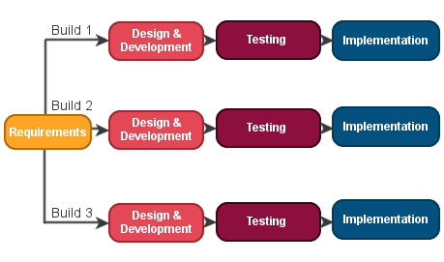

Basic Concepts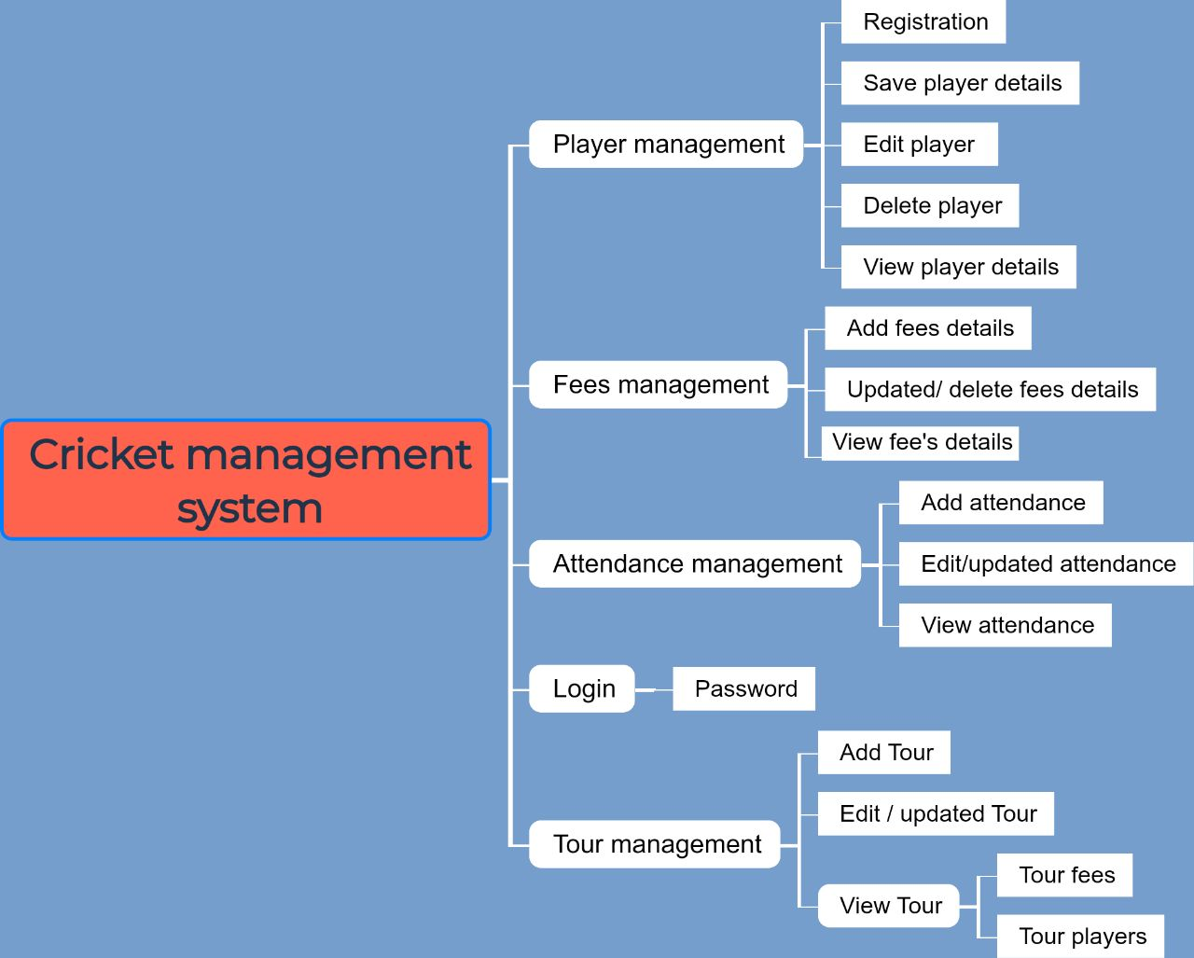

**MODULE DESCRIPTIONS**

* + **Login module**
    - Login
    - Change password
    - Logout
  + **Player module**
    - Player registration module
    - Deleted player
    - View player details
    - Updated player details
    - Search player
  + **Attendance module** 
    - Add player attendance
    - Updated attendance
    - View player attendance
  + **Fees module** 
    - Add fee's structure
    - Add/updated player fee
    - View player fees details
  + **Tour module**
    - Add player and selects tour
    - View player selected tour details
    - Add tour fees
    - View tour fees

**ADMINISTRATOR MODULE: OWNER AND MANAGER**

**Chapter 4**

**SYSTEM DESIGN**

**These activity diagram shapes and symbols are some of the most common types you'll find in UML diagrams.**

1. **Start symbol:** Represents the beginning of a process or workflow in an activity diagram. It can be used by itself or with a note symbol that explains the starting point.
2. 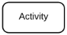**Activity symbol:** Indicates the activities that make up a modeled process. These symbols, which include short descriptions within the shape, are the main building blocks of an activity diagram.
3. **Connector symbol:** Shows the directional flow, or control flow, of the activity. An incoming arrow starts a step of an activity; once the step is completed, the flow continues with the outgoing arrow.
4. **Decision symbol:** Represents a decision and always has at least two paths branching out with condition text to allow users to view options. This symbol represents the branching or merging of various flows with the symbol acting as a frame or container.
5. **End symbol:** Marks the end state of an activity and represents the completion of all flows of a process.

**Cricket Management System Activity Diagram**

This is the Activity UML diagram of cricket management system which shows the flows between the activity of attendance, fees, tour and player. The main activity involved in this Uml activity diagram are as follows:

* Player activity
* Attendance activity
* Tour activity
* Fees activity

Features of the Activity Uml diagram of cricket management system

* Admin User can search player, view description of a selected player, add player, update player details.
* Its shows the activity flow of adding and updating player
* User will be able to search of player attendance, fees and tour details.

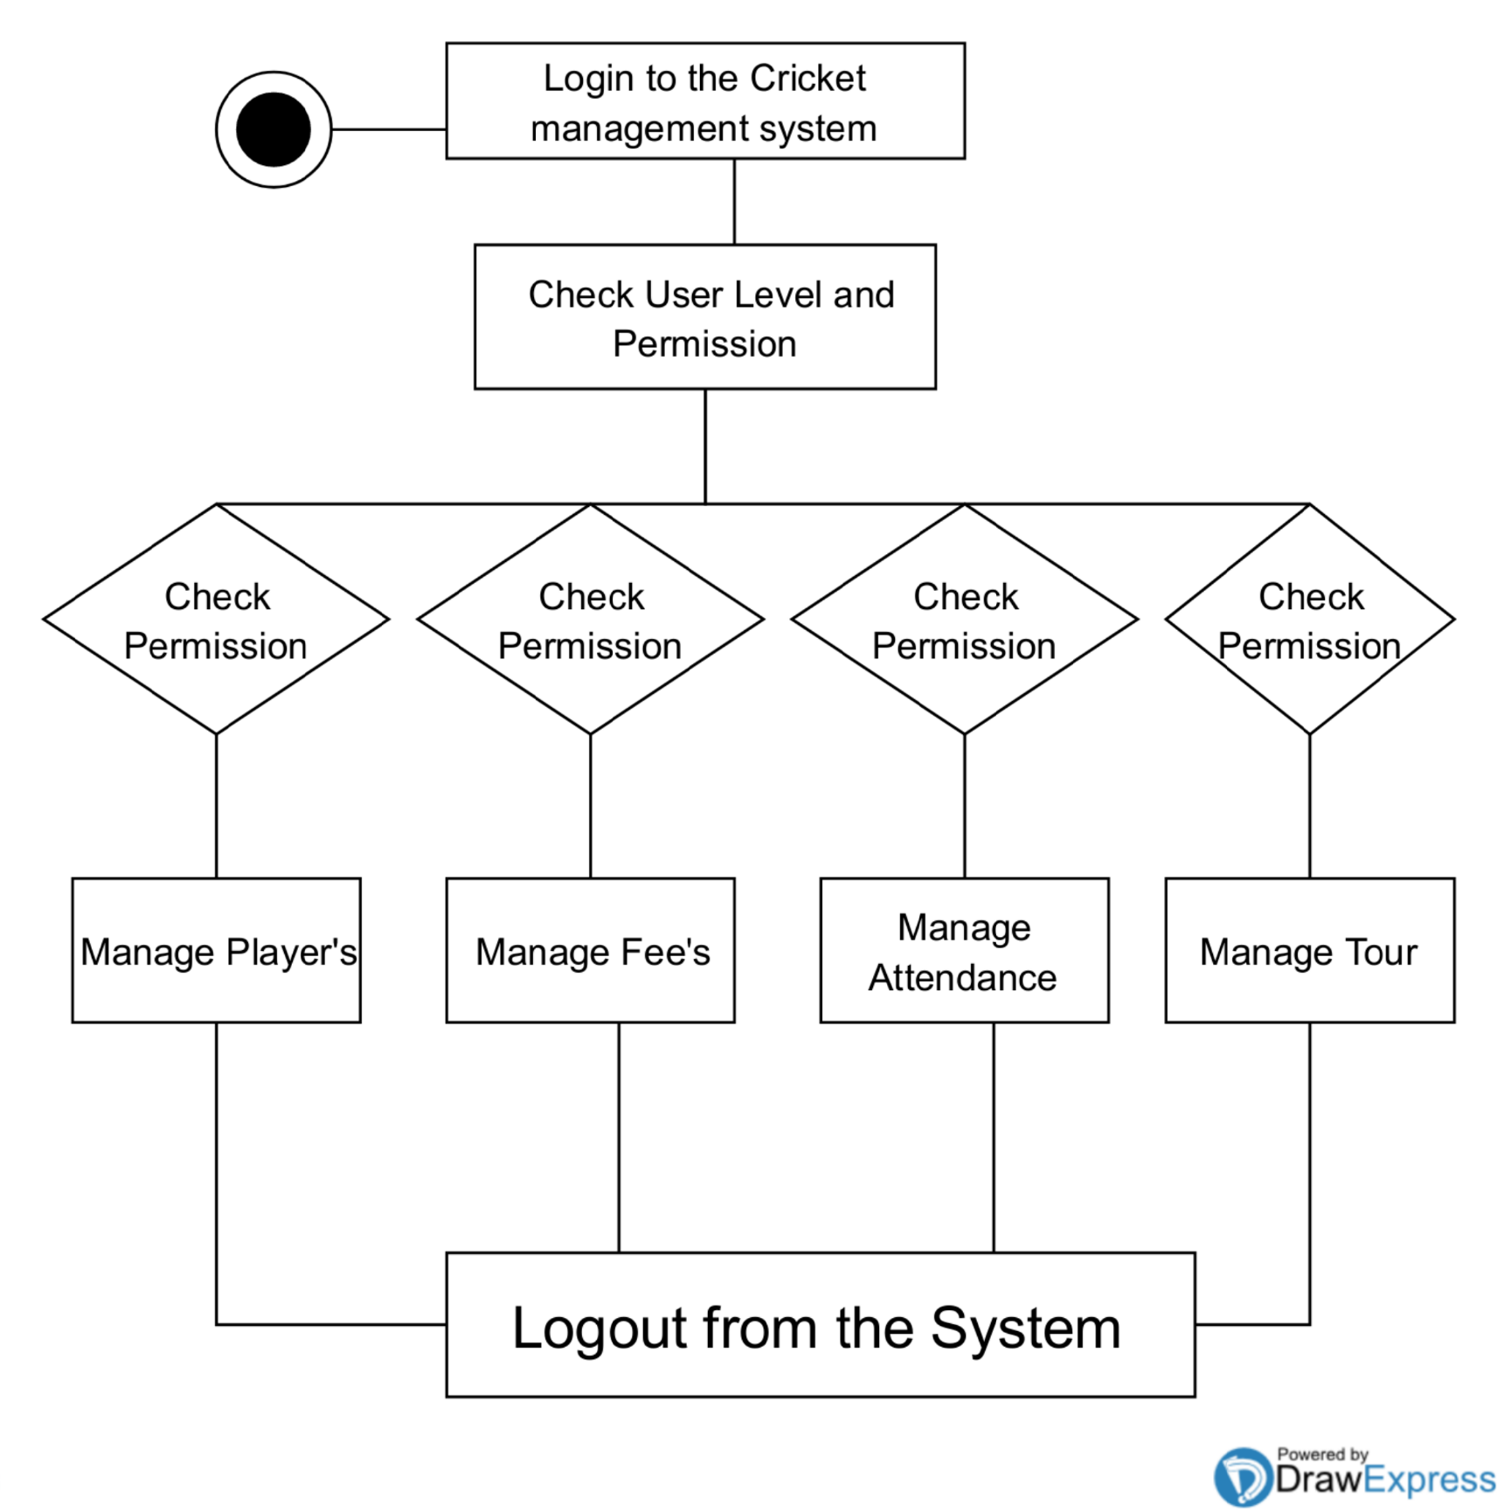

**Login Activity diagram of cricket management system.**

This is the login activity diagram of cricket management system which shows the flows of login activity, where admin will be able to login using their username and password. After login user can manage all the operations on attendance, fees, tour, and player details. All the pages such attendance, fees, tour are secure and user can access these page after login. The diagram below helps demonstrate how the login page works in a cricket management system. The various objects in the page – interact over the course of the Activity, and user will not be able to access this page without verifying their identify.

**Cricket management system class diagram**

Cricket management class diagram describes the structure of a cricket management classes, their attributes, operations (or methods), and the relationships among objects. The main

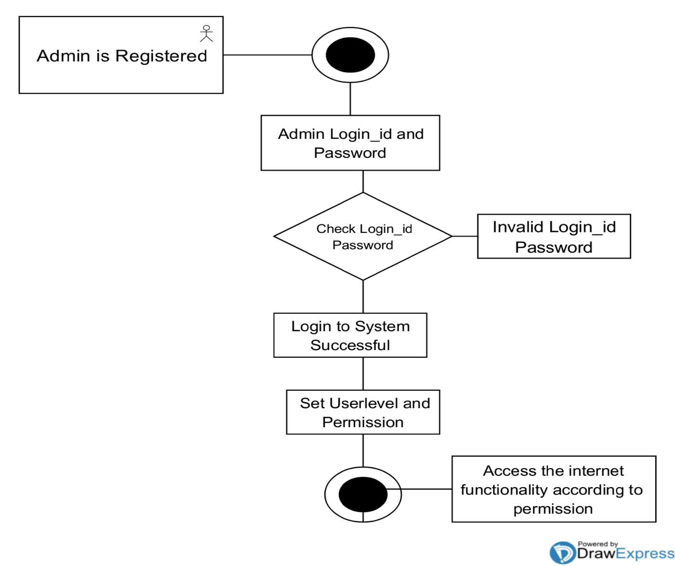classes of the cricket management system are fees, attendances, tour, player

**Entity Relationship Diagram:**

An entity relationship diagram (ERD) shows the relationships of entity sets stored in a database. An entity in this context is an object, a component of data. An entity set is a collection of similar entities. These entities can have attributes that define its properties. By defining the entities, their attributes, and showing the relationships between them, an ER diagram illustrates the logical structure of databases. ER diagrams are used to sketch out the design of a database.

**Symbols**

An ER diagram is a means of visualizing how the information a system produces is related. There are five main components of an ERD:

1. 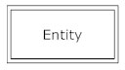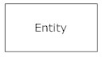**Entities**, which are represented by rectangles. An entity is an object or concept about which you want to store information.  A weak entity is an entity that must defined by a foreign key relationship with another entity as it cannot be uniquely identified by its own attributes alone.
2. 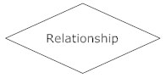**Actions**, which are represented by diamond shapes, show how two entities share information in the database.  In some cases, entities can be self-linked. For example, employees can supervise other employees.
3. 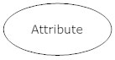**Attributes**, which are represented by ovals. A key attribute is the unique, distinguishing characteristic of the entity. For example, an employee's social security number might be the employee's key attribute.

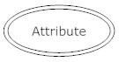 A multivalve attribute can have more than one value. For example, an employee entity can have multiple skill values.

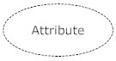 A derived attribute is based on another attribute. For example, an employee's monthly salary is based on the employee's annual salary.

1. **Connecting lines**, solid lines that connect attributes to show the relationships of entities in the diagram.
2. **Cardinality** specifies how many instances of an entity relate to one instance of another entity. Ordinality is also closely linked to cardinality. While cardinality specifies the occurrences of a relationship, ordinality describes the relationship as either mandatory or optional. In other words, cardinality specifies the maximum number of relationships and ordinality specifies the absolute minimum number of relationships.

**Classes of cricket management system**

Class diagram.

* Player class: manage all the operations of player
* Fees class: manage all the operations of fees
* Attendance class: manage all the operations of attendances.
* Tour class : manage all operations of tour.

**Classes and their attributes of cricket management class diagram.**

* Player Attributes: player_name, player_email, player_college_id, player_username, player_mobile, player_address, player_father_number.
* Fees Attributes: fees_id, fees_amount, fees_type, fees_description.
* Tour attributes: tour place, tour date, tour_type, tour_vehicle.
* Attendance Attributes: atten_date, atten_id.

**Classes and their methods of cricket management class diagram.**

* Player Methods: addPlayer(), editPlayer(), deletePlayer(), updatePlayer(), SavePlayer(), searchPlayer().
* Fees methods: addFees(), deleteFees(), editfees(), updatefees(), saveFees(), searchFees().
* Tour Methods: addTour(), deleteTour(), updateTour(), editTour(), saveTour(), searchTour().
* Attendance Methods: addAttendace(), deleteAttendance(), editeAttendace(), saveAttendance, searchAttendance().

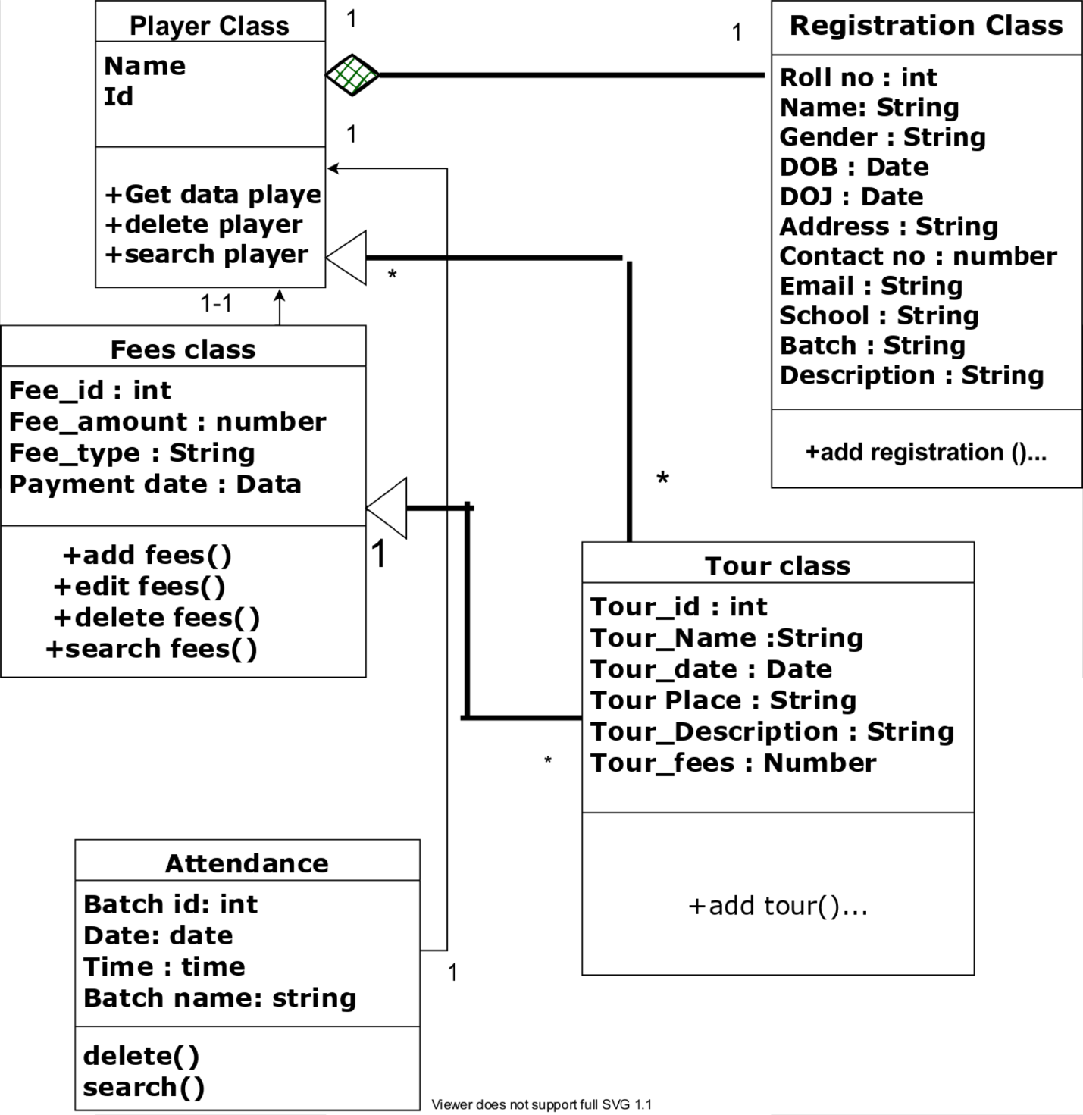

1. **Component Diagram:**

The purpose of a component diagram is to show the relationship between different components in a system. For the purpose of UML 2.0, the term "component" refers to a module of classes that represent independent systems or subsystems with the ability to interface with the rest of the system. There exists a whole development approach that revolves around components: component-based development (CBD). In this approach, component diagrams allow the planner to identify the different components so the whole system does what it's supposed to do. More commonly, in an OO programming approach, the component diagram allows a senior developer to group classes together based on common purpose so that the developer and others can look at a software development project at a high level.

**Component diagram shapes and symbols**

1. 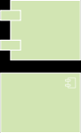**Component symbol:** An entity required to execute a stereotype function. A component provides and consumes behavior through interfaces, as well as through other components. Think of components as a type of class. In UML 1.0, a component is modeled as a rectangular block with two smaller rectangles protruding from the side. In UML 2.0, a component is modeled as a rectangular block with a small image of the old component diagram shape.
2. 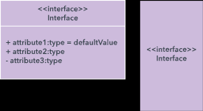**Interface symbol:** Shows input or materials that a component either receives or provides. Interfaces can be represented with textual notes or symbols, such as the lollipop, socket, and ball-and-socket shapes.
3. 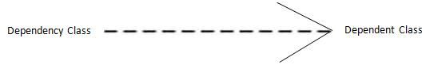**Dependency symbol:** Shows that one part of your system depends on another. Dependencies are represented by dashed lines linking one component (or element) to another.
4. 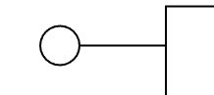**Provided interfaces:** A straight line from the component box with an attached circle. These symbols represent the interfaces where a component produces information used by the required interface of another component.
5. 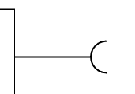**Required interfaces**: A straight line from the component box with an attached half circle (also represented as a dashed arrow with an open arrow). These symbols represent the interfaces where a component requires information in order to perform its proper function.

**Cricket management system component diagram**

This is a component diagram of cricket management system which shows components, provided and required interface, ports, and relationships between the attendance, tour, fees and player. This type of diagrams is used in component-based development to described systems with service-oriented architecture. Cricket management Uml component diagram describes the organization and writing of the physical components in a system.

Components of Uml component diagram of cricket management system.

* Attendance component
* Tour component
* Fees component
* Player component

Feature of cricket management system component diagram.

* You can show the models the component of cricket management system.
* Model the database schema of cricket management system.
* Model the executes of an application of cricket management system.
* Model the system’s source code of cricket management system.

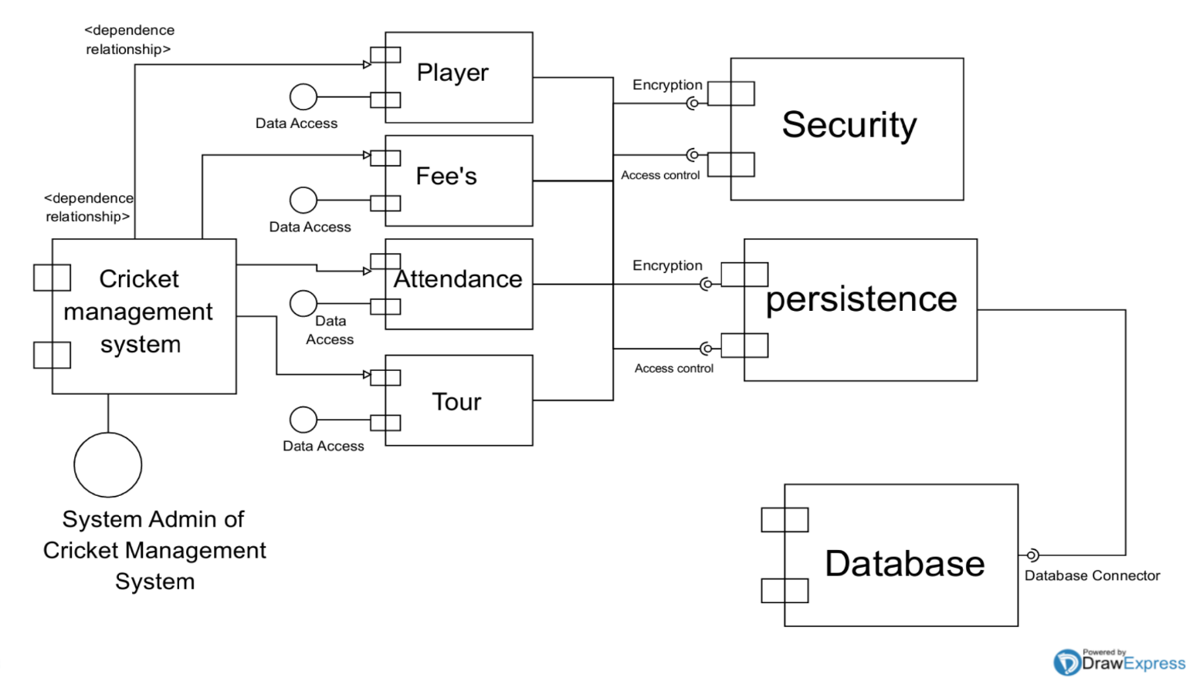

**The symbols depict the four components of data flow diagrams.**

1. 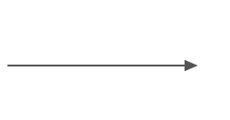**External entity:** an outside system that sends or receives data, communicating with the system being diagrammed. They are the sources and destinations of information entering or leaving the system. They might be an outside organization or person, a computer system or a business system. They are also known as terminators, sources and sinks or actors. They are typically drawn on the edges of the diagram.
2. 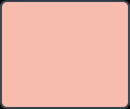**Process:** any process that changes the data, producing an output. It might perform computations, or sort data based on logic, or direct the data flow based on business rules. A short label is used to describe the process, such as “Submit payment.”
3. **Data store:** files or repositories that hold information for later use, such as a database table or a membership form. Each data store receives a simple label, such as “Orders.”
4. 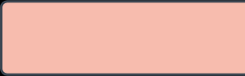**Data flow:** the route that data takes between the external entities, processes and data stores. It portrays the interface between the other components and is shown with arrows, typically labeled with a short data name, like “Billing details.”
5. **Class Diagram:**

One of the more popular types in UML is the class diagram. Popular among software engineers to document software architecture, class diagrams are a type of structure diagram because they describe what must be present in the system being modeled. No matter your level of familiarity with UML or class diagrams, our [UML software](https://www.lucidchart.com/pages/examples/uml_diagram_tool) is designed to be simple and easy to use.

UML was set up as a standardized model to describe an object-oriented programming approach. Since classes are the building block of objects, class diagrams are the building blocks of UML. The various components in a class diagram can represent the classes that will actually be programmed, the main objects, or the interactions between classes and objects.

The class shape itself consists of a rectangle with three rows. The top row contains the name of the class, the middle row contains the attributes of the class, and the bottom section expresses the methods or operations that the class may use. Classes and subclasses are grouped together to show the static relationship between each object.

**Basic components of a class diagram**

The standard class diagram is composed of three sections:

1. **Upper section:**Contains the name of the class. This section is always required, whether you are talking about the classifier or an object.
2. **Middle section:**Contains the attributes of the class. Use this section to describe the qualities of the class. This is only required when describing a specific instance of a class.
3. **Bottom section:**Includes class operations (methods). Displayed in list format, each operation takes up its own line. The operations describe how a class interacts with data.

**Member access modifiers**

All classes have different access levels depending on the access modifier (visibility). Here are the access levels with their corresponding symbols:

* Public (+)
* Private (-)
* Protected (#)
* Package (~)
* Derived (/)
* Static (underlined)

**Cricket management Dataflow diagram**

Cricket management date flow diagram is often used as a preliminary step to create an overview of the cricket without going into great detail, which can later be elaborated. It normally consists of overall application dataflow and processes of the cricket process. It contains all of the user flow and their entities such all the flow of cricket player, fees, attendance, and tour, login. All of the below diagrams has been used for the visualization of data processing and structure trued design go the cricket process working flow.

**Zero level data flow diagram**

This is the zero level DFD of the Cricket management system, it’s a basic overview of the Cricket management and process being analyzed or modeled. It’s designed to be a glance view of player, attendance, fees, tour and login. It should be easily understood by a wild audience, including tour, fees, attendance and player in zero level DFD of cricket management system, we have described the high level flow of the cricket system.

High level entities and process flow of cricket management:

* Managing all the players
* Managing all the fees
* Managing all the tour
* Managing all the attendance
* Managing all the login

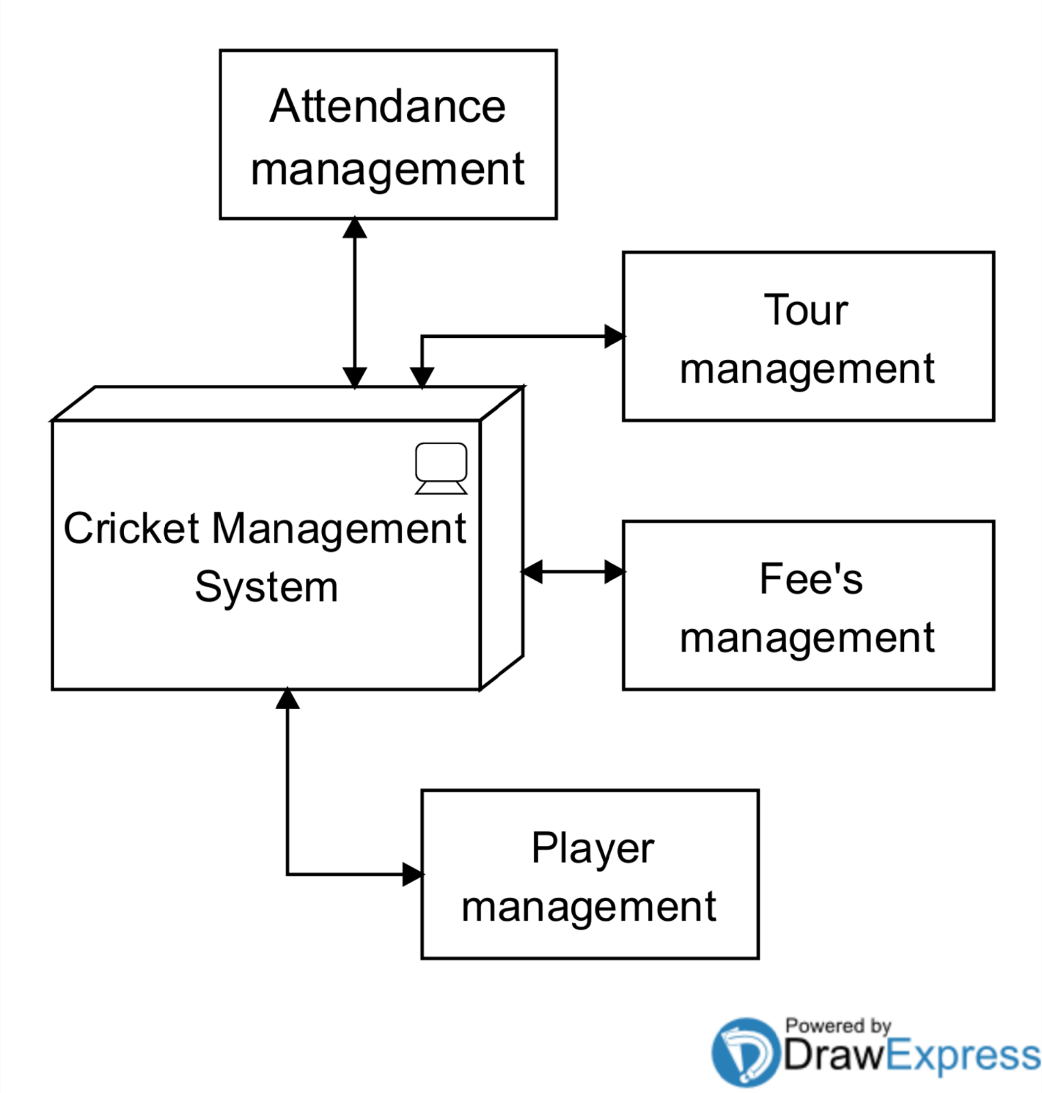

**First** level data flow diagram of cricket management system

Main entities and output of first level DFD

* Processing Attendance records and generated report of all attendees
* Processing fees record and generated report of all fee’s
* Processing Tour record and generated report of all tour activities
* Processing login record. And generated report of all logon

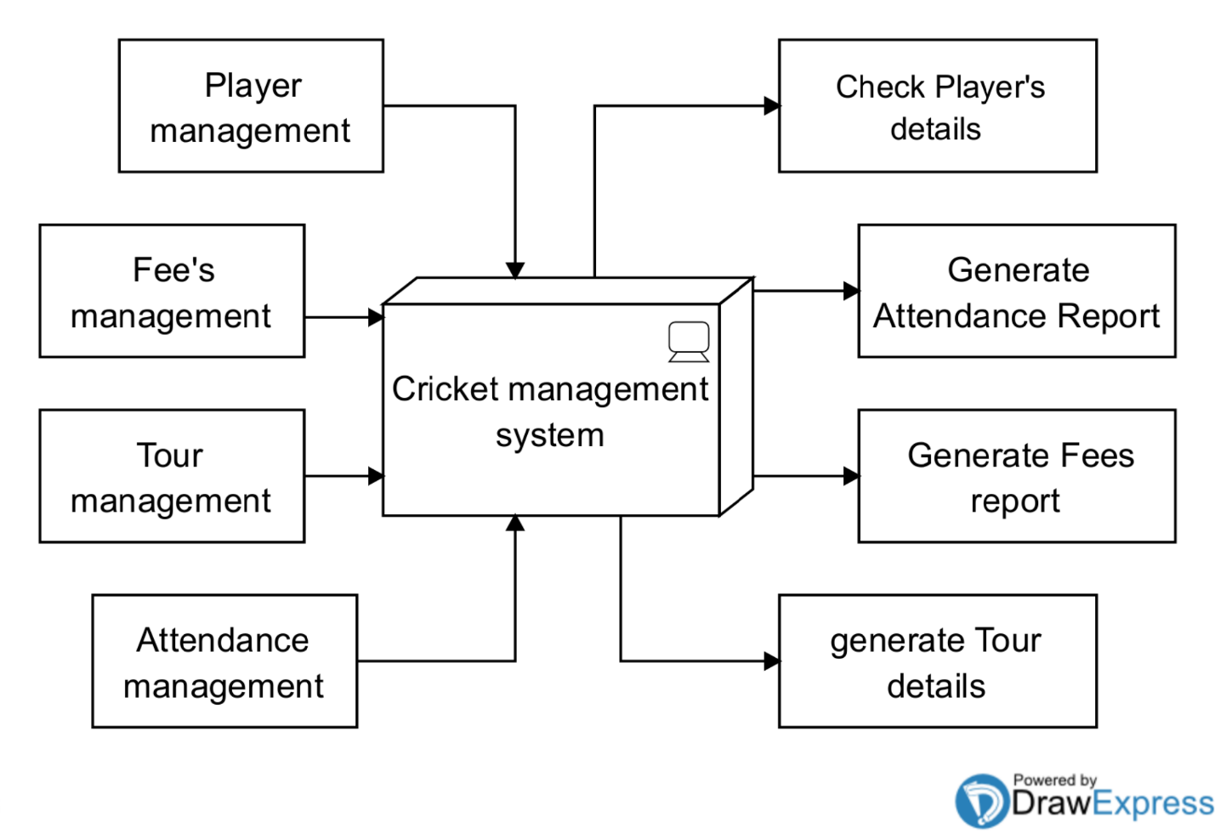

**Second** level data flow diagram of cricket management system.

Low level functionality of cricket management system

* Admin login to the system and manage all the functionality of cricket management system.
* Admin can edit, delete, updated, view details of cricket management system
* Admin can manage all details of players, tour, attendance and fees.
* Admin can search details of attendance, tour, fees and player
* Admin can track details information of players, attendance, tour and fees.

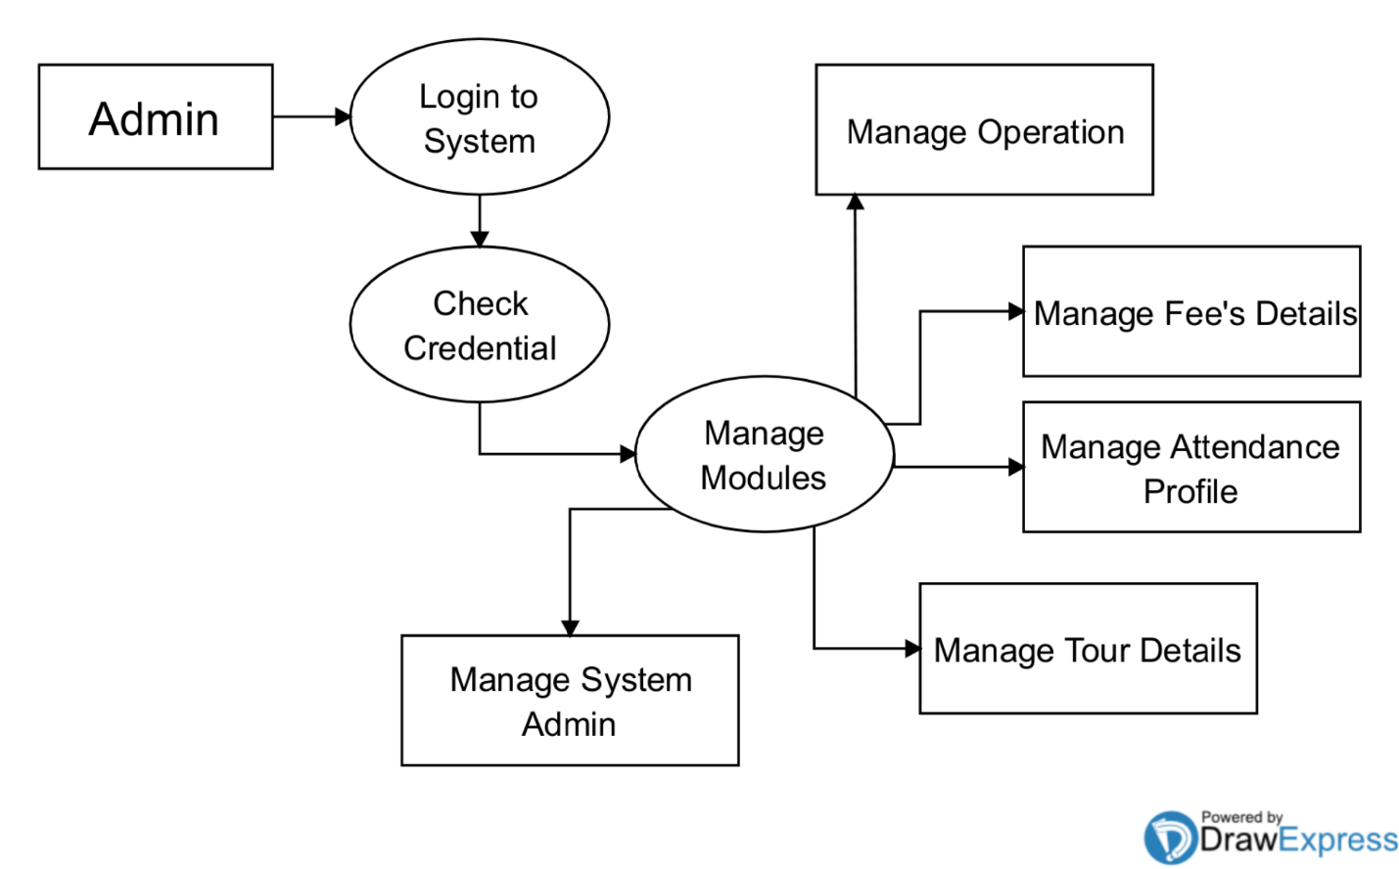

**Entity relationship diagram**

This ER (Entity Relationship) Diagram represents the model of Cricket Management Entity. The entity-relationship diagram of Cricket Management shows all the visual instrument of database tables and the relations between Fees, Cricket, player etc. It used structure data groups of Cricket Management functionalities. The main entities of the Cricket Training Management are Cricket players, Fees.

**Cricket Management entities and their attributes:**

Players Entity : Attributes of Players are player_id, player_college_id, player_name, player_mobile, player_email, player_address

Fees Entity : Attributes of Fees are fees_id, fees_amount, fees_type, fees_description

Attendance Entity: batch_name, , class_time, date.

Tour Entity: Tour_id, Tour_place, Tour_date, Tour_name, Tour_description, Tour_fees.

Description of Cricket Training Management Database:

**.**The details of Cricket is store into the Cricket tables respective with all table

Each entity (Players, Tour, fees, and attendance) contains primary key and unique keys.

* The entity Players, Schedules has banded with Cricket, Trainer entities with foreign key
* There is one-to-one and one-to-many relationships available between tour, Fees, players Cricket
* All the entities Players are normalized and reduce delicacy of records
* 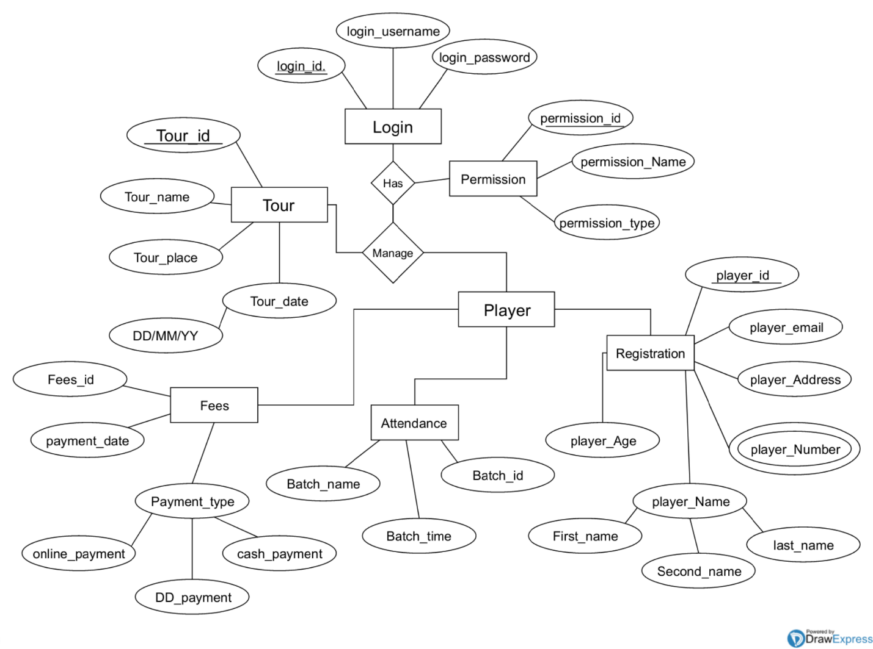We have implemented indexing on each tables of Cricket

**Logic diagram of cricket management system**

The Relationship between two entities like Attendance and player are one to one relationship one player are one attendance.

In a relationship database, a one to many relationship are when one player apply more than one tour. And many too many relationship refers to a relationship between table in a database.

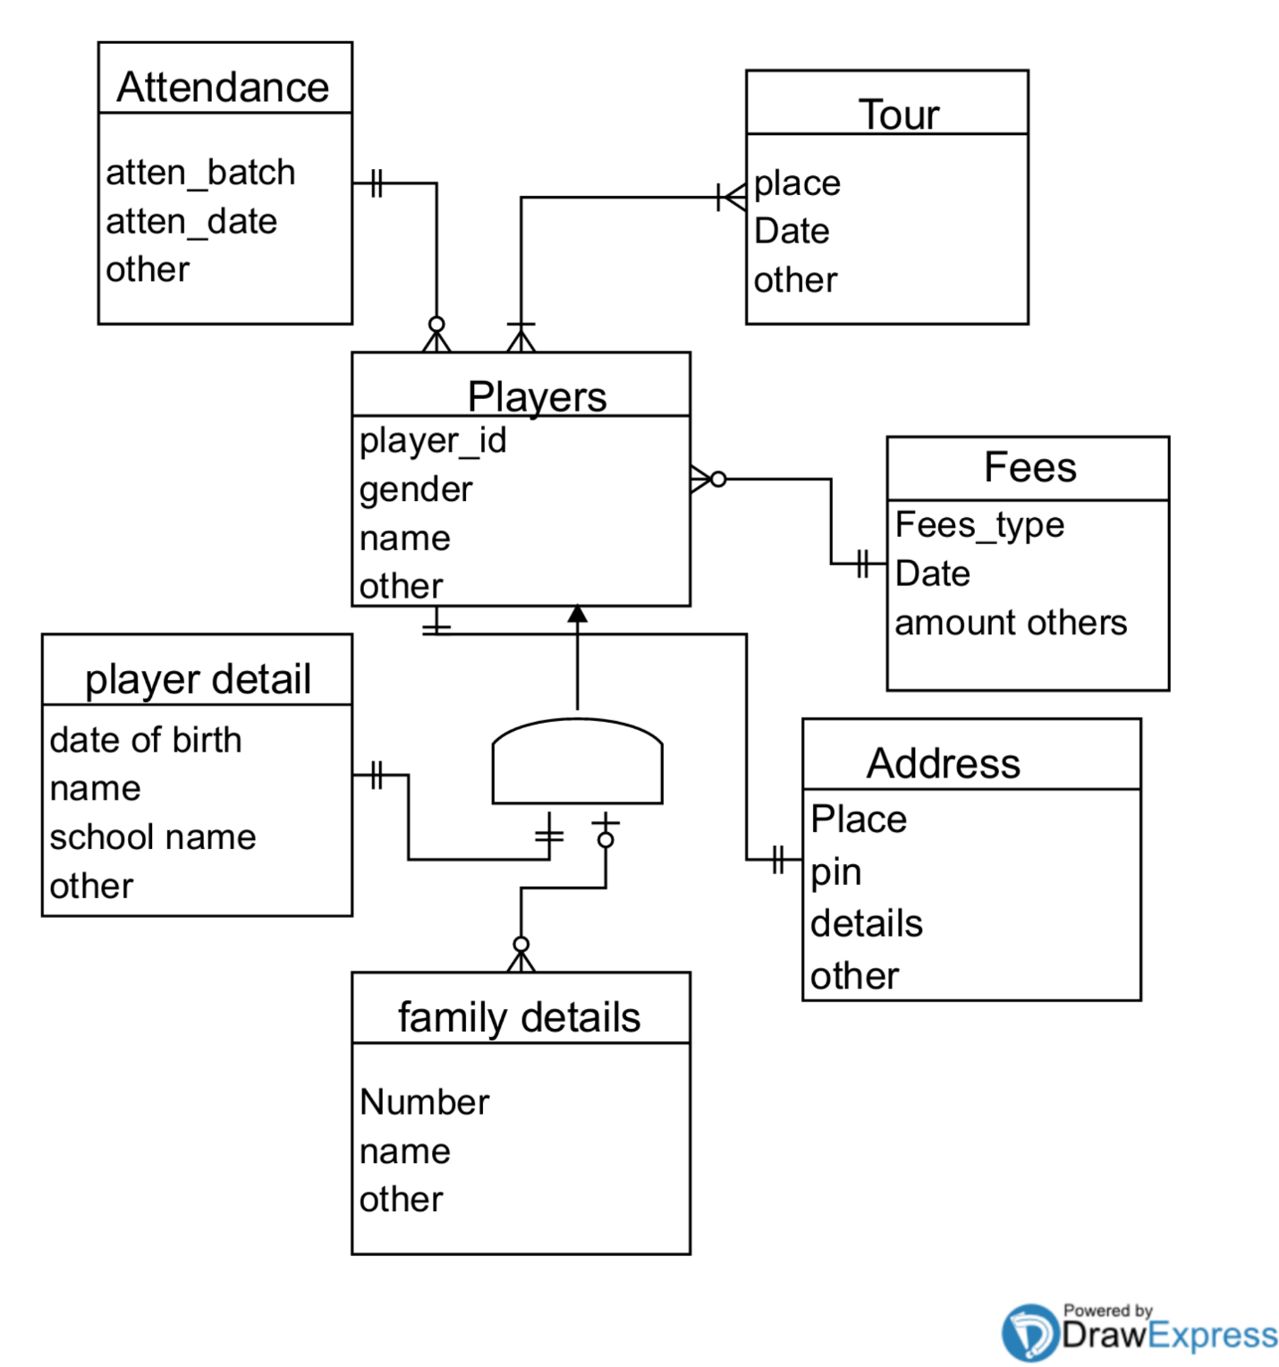

1. **Object symbol:** Represents a class or object in UML. The object symbol demonstrates how an object will behave in the context of the system. Class attributes should not be listed in this shape.
2. **Activation box:** Represents the time needed for an object to complete a task. The longer the task will take, the longer the activation box becomes.

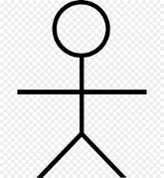

1. **Actor symbol:** Shows entities that interact with or are external to the system.
2. **Lifeline symbol:** Represents the passage of time as it extends downward. This dashed 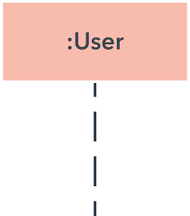vertical line shows the sequential events that occur to an object during the charted process. Lifelines may begin with a labeled rectangle shape or an actor symbol.

**Common message symbols**

1. **Synchronous message symbol:** Represented by a solid line with a solid arrowhead. This symbol is used when a sender must wait for a response to a message before it continues. The diagram should show both the call and the reply.
2. **Asynchronous message symbol:** Represented by a solid line with a lined arrowhead. Asynchronous messages don't require a response before the sender continues. Only the call should be included in the diagram.
3. **Asynchronous return message symbol:** Represented by a dashed line with a lined arrowhead.
4. **Reply message symbol:** Represented by a dashed line with a lined arrowhead, these messages are replies to calls.

**Cricket Management System Sequence Diagram**

This is the UML sequence diagram of Cricket Training Management System which shows the interaction between the objects of Players, fees , attendance, tour. The instance of class objects involved in this UML Sequence Diagram of Cricket Training Management System are as follow

* Players Object
* Attendance Object
* Tour Object
* Fee’s Object.

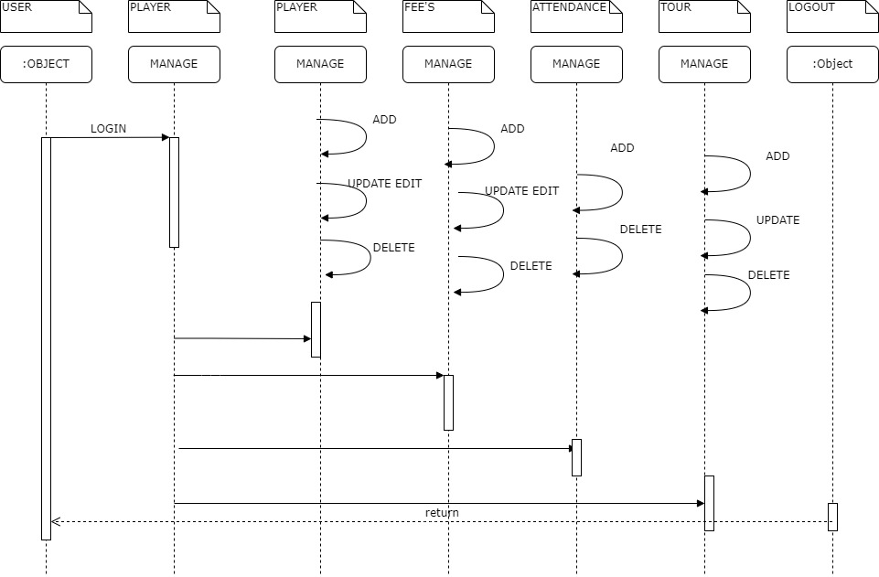

**Cricket Management Use Case Diagram**

This Use Case Diagram is a graphic depiction of the interactions among the elements of Cricket Management. It represents the methodology used in system analysis to identify, clarify, and organize sys tem requirements of Cricket Management main actors of Cricket Management in this Use Case Diagram are only one Super Admin or System User, who perform the different type of use cases such as Manage Cricket, Manage Players, Manage Fees, Manage Attendance, Manage Users and Full Cricket Management Operations. Major elements of the UML use case diagram of Cricket Training Management are shown on it below diagram

Super Admin Entity : Use cases of Super Admin are Manage Cricket, Manage Trainer, Manage Players, Manage Fees, Manage Schedules, , Manage Attendance, Manage Users and Full Cricket Training Management Operations

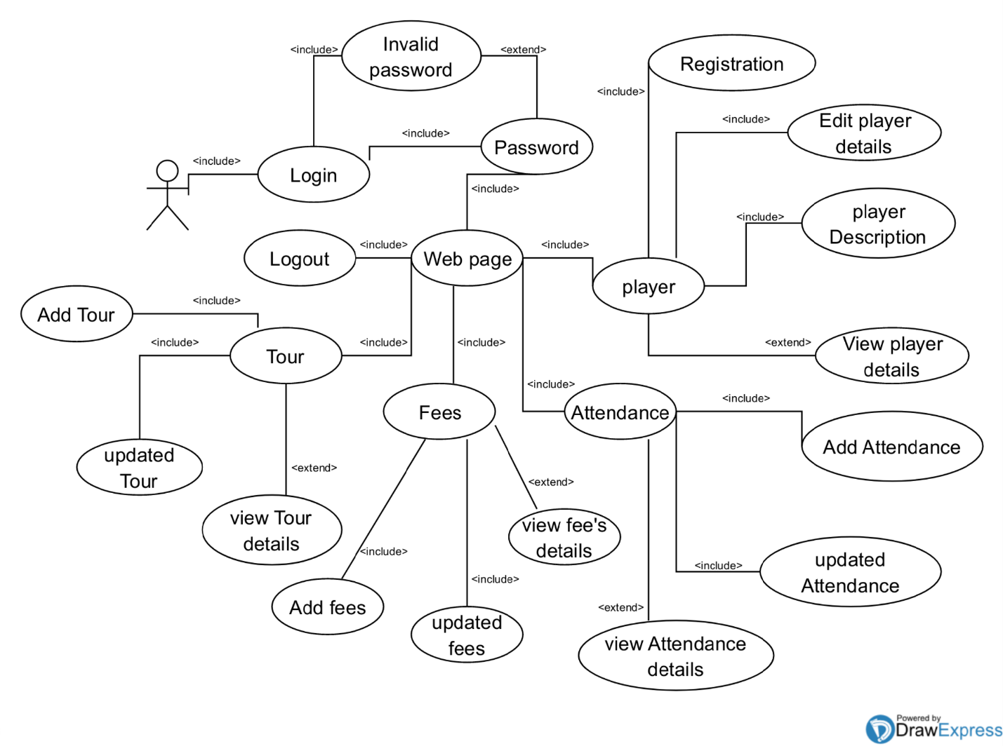

**Constraints**

**Constraints**

Player Constraints

|  |  |  |  |
| --- | --- | --- | --- |
| **Attribute** | **Data** **type** | **Constraints** | **Size** |
| ROLL_NO | Int | Primary key  Foreign key | 50 |
| Name | String | Not Null | 20 |
| Gender | String | Not Null | 5 |
| DOB | Date | Not null | Date |
| DOJ | Date | Not Null | Date |
| Address | String | Default | 20 |
| Email | var char | Default | 20 |
| Contact _Number | Int | Not Null | 10 |
| School name | String | Default | 20 |
| Description | String | Default | 30 |

Fee’s Constraints

|  |  |  |  |
| --- | --- | --- | --- |
| **Attribute** | **Data type** | **Constraints** | **Size** |
| feeid | Int | Foreign key | 30 |
| Fee’s Type | varchar | Default | 30 |
| Uniform fee | Float | Not Null | 50 |
| Academic fee | Float | Not Null | 50 |
| Kit fee | Float | Not Null | 50 |
| Total | Float | Not Null | 50 |
| Balance | Float | Not Null | 50 |

**Attendance**

|  |  |  |  |
| --- | --- | --- | --- |
| **Attribute** | **Data Type** | **Constraints** | **Size** |
| Roll No | Int | Foreign key | 30 |
| Present Date | Int | Default |  |
| Absent Date | Int | Default |  |

**Tour**

|  |  |  |  |
| --- | --- | --- | --- |
| **Attribute** | **Data Type** | **Constraint** | **Size** |
| Tour id/roll no | Int | Foreign key | 30 |
| Tour player | varchar | Default | 30 |
| Tour Date | Date | Default | 30 |
| Tour Name | String | Not null | 30 |
| Tour description | String | Default | 30 |
| Tour fees | Float | Default | 30 |

**Test cases Design**

**USER:**

1. **REGISTRATION:**

|  |  |  |  |
| --- | --- | --- | --- |
| **ID** | **TEST CASE** | **USER INPUT** | **PASS CIRTERIA** |
| U_REG_2 | User Registration | User forgets to enter a particular required field | Display message the value in the field is required. |
| U_REG_3 | User Registration | User enters different password in password confirm field | Display message that password and confirm password field don’t match. |
| U_REG_4 | User Registration | User enters all the field successfully | User account created. |

1. **Login:**

|  |  |  |  |
| --- | --- | --- | --- |
| **ID** | **TEST CASE** | **USER INPUT** | **PASS CRITERIA** |
| U_LOG_1 | User Login | User enters a wrong username | Display message login or password is incorrect. |
| U_LOG_2 | User Login | User enters a wrong password | Display message login or password is incorrect. |
| U_LOG_3 | User Login | User enters a correct username and password | User logs in successfully. |

1. **Player**

|  |  |  |  |
| --- | --- | --- | --- |
| **ID** | **TEST CASE** | **USER INPUT** | **PASS CRITERIA** |
| U_LOG_1 | Add Player | User Enter a player details | Display View player page and generate id |
| U_LOG_2 | View Player | User edit Delete a player | If User click edit display edit page or if user click deleted then player will be deleted |
| U_LOG_3 | Updated Player | User Search a Player id and update the details | Display view page with update information |
| U_LOG_4 | Delete Player | User Enter player id Roll number | Display message player is deleted or nothing is happen |

1. **FEE’S**

|  |  |  |  |
| --- | --- | --- | --- |
| **ID** | **TEST CASE** | **USER INPUT** | **PASS CRITERIA** |
| U_LOG_1 | Add Player Fees | Search a player by id and fill the fees information | Display the view fee table and generate the fees id |
| U_LOG_2 | View Fees | User can Update, edit a fees details | If User click update display update page or if user click deleted then fees details will be deleted |
| U_LOG_3 | Search Fees | User can search a Fees by fee_id and update and deleted a details | If User click update display update page or if user click deleted then fees details will be deleted |

1. **Tour**

|  |  |  |  |
| --- | --- | --- | --- |
| **ID** | **TEST CASE** | **USER INPUT** | **PASS CRITERIA** |
| U_LOG_1 | Add Tour | User Enter a Tour details | Display View Tour page and generate id |
| U_LOG_2 | View Tour | User can Update, edit a Tour details | If User click update display update page or if user click deleted then Tour details will be deleted |
| U_LOG_3 | Search Tour | User can search a Tour by tour_id and update and deleted a details | If User click update display update page or if user click deleted then Tour details will be deleted |

Chapter 5

IMPLEMENTATION

AND TESTING

* 1. **Implementation Approaches:**

**1.Discovery & Planning**

This phase is the foundation upon which the entire project is planned and developed. It involves detailed requirement gathering, where in key pieces of information such as scope, objective, wireframes and functional requirements for the project are discussed and documented.

Discovery phase is the most important step in the whole application development process as it gives a clear understanding of the purpose, business goals, and target audience. Based on these inputs, a well thought out action plan comprising task breakdown, resource allocation, project timelines and milestones, is prepared.

**2.Design & UI Coding**

Wireframes and guidelines gathered in the previous phase are used as guidelines to design the website. The look and feel of the website is very important for successful engagement and retention of target audience. Usually, the design team creates more than one prototype of the design, and it is further refined based on inputs from the client.

Aside from other things, an attractive site design is essential to ensure better traffic and conversion rate. After finalizing the design, the front-end code has been written.

**3.Development**

In the development phase, functional elements of the website are built. While writing the backend code the features/functionalities that were finalized in the discovery phase. This involves coding the business logic, integrating user interface with the backend database.

**4.Quality Control**

Before a newly built web application can be reviewed, it is essential to ensure that it has met rigorous quality standards. In this phase, a comprehensive quality assurance of the various developed features is performed. Browser responsive testing, regression testing, functional testing, smoke testing, load testing and performance testing are the main types of quality assurance tests performed here. Iterative process is done to guarantee the final product is bug free and smooth.

LOGIN

**Login.php**

<?php include 'landing.php';

?>

<?php

if(isset($_POST['login'])){

$conn = mysqli_connect("localhost","root","","cms")or die("connection lost");

$ply_username=$_POST['username'];

$ply_password=$_POST['password'];

$fng=1;

$sql="SELECT * FROM user WHERE username='$ply_username' AND password = '$ply_password'";

$result = mysqli_query($conn,$sql)or die("connection failed");

$num= mysqli_num_rows($result);

if($num==1){

session_start();

$_SESSION['loggedin']=True;

$_SESSION['username']=$ply_username;

header("Location: http://localhost/cms/welcome/welcome.php");

}

else{

?>

<script>

alert("Incorrect Password");

</script>

<?php

}

}

?>

<div class="center">

<h1 >Login</h1>

<form action="<?php echo $_SERVER['PHP_SELF']; ?>" method="post">

<div class="txt_field">

<input type="text" id="username" name="username" required>

<span></span>

<label>Username</label>

</div>

<div class="txt_field">

<input type="password" id="password" name="password" required>

<span></span>

<label>Password</label>

</div>

<!-- <div class="pass">Forgot Password?</div> -->

<input type="submit" name="login" value="Login">

<div class="signup_link">

Not a member? <a href="#">Connact with Owner</a>

</div>

</form>

</div>

**Loginsystem.php**

<?php

$conn = mysqli_connect("localhost","root","","cms")or die("connection lost");

$ply_username=$_POST['username'];

$ply_password=$_POST['password'];

$sql="SELECT * FROM user WHERE username='$ply_username' AND password = '$ply_password'";

$result = mysqli_query($conn,$sql)or die("connection failed");

$num= mysqli_num_rows($result);

if($num==1){

session_start();

$_SESSION['loggedin']=True;

$_SESSION['username']=$ply_username;

header("Location: http://localhost/cms/welcome/welcome.php");

}

else{

header("Location: http://localhost/login/sign.php");

}

?>

HOME

**Welcome.php**

<?php include '../header/header.php'; ?>

<?php

session_start();

if(!isset($_SESSION['loggedin']) || $_SESSION['loggedin']!=TRUE){

header("Location: http://localhost/login/sing.php");

exit;

}

?>

<link rel="stylesheet" href="css/sty.css">

<main>

<section>

<h3></h3>

<h1>Welcome <?php echo $_SESSION['username']?> </h1>

<p>“No matter how hot the fire burns, a protea always survives.” – AB Devilliers</p>

<a href="../contact/index.php" class="btn41-43 btn-41" >Contact Us</a>

<a href="../signup/sign.php" class="btntwo">signup here</a>

</section>

</main>

</body>

</html>

Sign.php

<?php include '../header/header.php';

?>

<link rel="stylesheet" href="css/sign.css">

<div class="container">

<div class="title">Registration</div>

<div class="content">

<form action="signout.php" method="post">

<div class="user-details">

<div class="input-box">

<span class="details">Full Name</span>

<input type="text" id="pname" name="pname" placeholder="Enter your name" required>

</div>

<div class="input-box">

<span class="details">Username</span>

<input type="text" id="username" name="username" placeholder="Enter your username" required>

</div>

<div class="input-box">

<span class="details">Email</span>

<input type="email" id="gmail" name="gmail" placeholder="Enter your email" required>

</div>

<div class="input-box">

<span class="details">Phone Number</span>

<input type="text" id="phone" name="phone" placeholder="Enter your number" required>

</div>

<div class="input-box">

<span class="details">Password</span>

<input type="text" id="password" name="password" placeholder="Enter your password" required>

</div>

<div class="input-box">

<span class="details">Confirm Password</span>

<input type="text" id="cpassword" name="cpassword" placeholder="Confirm your password" required>

</div>

</div>

<div class="button">

<input type="submit" value="Register">

</div>

</form>

</div>

</div>

Signout.php

<?php

$conn = mysqli_connect("localhost","root","","cms")or die("connection lost");

$ply_uname=$_POST['pname'];

$ply_username=$_POST['username'];

$ply_gmail=$_POST['gmail'];

$ply_phone=$_POST['phone'];

$ply_password=$_POST['password'];

$ply_cpassword=$_POST['cpassword'];

$exists = false;

$conn = mysqli_connect("localhost","root","","cms")or die("connection lost");

if(($ply_password==$ply_cpassword) && $exists==false ){

$sql="INSERT user(uname,username,gmail,phone,password) VALUE ('$ply_uname','$ply_username','$ply_gmail','$ply_phone','$ply_password')";

$result = mysqli_query($conn,$sql)or die("connection failed");

header("Location: http://localhost/cricket/login/login.php");

}

else{

header("Location: http://localhost/cms/signup/sign.php");

}

?>

HEADER

Header.php

<!DOCTYPE html>

<html lang="en" dir="ltr">

<head>

<meta charset="utf-8">

<meta name="viewport" content="width=device-width, initial-scale=1.0">

<title>Sidebar menu With Sub-menus | Using HTML, CSS & JQuery</title>

<link rel="stylesheet" href="../css/maincss.css">

<link rel="stylesheet" href="../css/player44.css">

<link rel="stylesheet" href="https://cdnjs.cloudflare.com/ajax/libs/font-awesome/5.15.1/css/all.min.css">

<script src="https://cdnjs.cloudflare.com/ajax/libs/jquery/3.5.1/jquery.min.js" charset="utf-8"></script>

</head>

<body>

<div class="menu-btn">

<i class="fas fa-bars"></i>

</div>

<div class="side-bar">

<div class="close-btn">

<i class="fas fa-times"></i>

</div>

<div class="menu">

<div class="item"><a href="../welcome/welcome.php"><i class="fas fa-desktop"></i>Dashboard</a></div>

<div class="item">

<a class="sub-btn"><i class="fas fa-table"></i>Player<i class="fas fa-angle-right dropdown"></i></a>

<div class="sub-menu">

<a href="../player/player_add.php" class="sub-item">ADD Player</a>

<a href="../player/player_view.php" class="sub-item">View Player</a>

<a href="../player/player_update.php" class="sub-item">Update Player</a>

<a href="../player/player_delete.php" class="sub-item">Delete Player</a>

</div>

</div>

<div class="item">

<a class="sub-btn"><i class="fas fa-table"></i>Fee's<i class="fas fa-angle-right dropdown"></i></a>

<div class="sub-menu">

<a href="../fee/feetable.php" class="sub-item">Fee's Table</a>

<a href="../fee/fee_add.php" class="sub-item">Add Fee's</a>

<a href="../fee/viewfee.php" class="sub-item">View Fee's</a>

</div>

</div>

<div class="item">

<a class="sub-btn"><i class="fas fa-book"></i>Attendance<i class="fas fa-angle-right dropdown"></i></a>

<div class="sub-menu">

<a href="../attendance/get_attendance.php" class="sub-item">Add Attendance</a>

<a href="../attendance/view_all.php" class="sub-item">View Attendance</a>

<!-- <a href="../attendance/#" class="sub-item">Sub Item 03</a> -->

</div>

</div>

<div class="item">

<a class="sub-btn"><i class="fas fa-cogs"></i>Tour<i class="fas fa-angle-right dropdown"></i></a>

<div class="sub-menu">

<a href="../tour/tour_add.php" class="sub-item"> ADD Tour</a>

<a href="../tour/tour_view.php" class="sub-item">Tour View</a>

<a href="../tour/tour_search.php" class="sub-item">Search Tour</a>

<!-- <a href="../ptour/Tour_player.php" class="sub-item">Tour Player</a> -->

</div>

</div>

<div class="item"><a href="../login/login.php"><i class="fas fa-desktop"></i>LOGOUT</a></div>

</div>

</div>

<script type="text/javascript">

$(document).ready(function(){

//jquery for toggle sub menus

$('.sub-btn').click(function(){

$(this).next('.sub-menu').slideToggle();

$(this).find('.dropdown').toggleClass('rotate');

});

//jquery for expand and collapse the sidebar

$('.menu-btn').click(function(){

$('.side-bar').addClass('active');

$('.menu-btn').css("visibility", "hidden");

});

$('.close-btn').click(function(){

$('.side-bar').removeClass('active');

$('.menu-btn').css("visibility", "visible");

});

});

</script>

</body>

</html>

CONTACT

**Contact.php**

<!DOCTYPE html>

<html lang="en">

<head>

<meta charset="UTF-8">

<meta http-equiv="X-UA-Compatible" content="IE=edge">

<meta name="viewport" content="width=device-width, initial-scale=1.0">

<title>Contact us</title>

<link rel="stylesheet" href="style.css">

</head>

<body>

<div class="container">

<h1>Contact form</h1>

<form action="https://formsubmit.co/pandasujit28@gmail.com" method="POST">

<input type="text" name="Name" placeholder="Full Name" required>

<input type="email" name="Email" placeholder="Email" required>

<textarea name="Message" placeholder="Message" required></textarea>

<button type="submit">Send</button>

</form>

</div>

</body>

</html>

CONFIG

**Config.php**

<?php

$conn = mysqli_connect("localhost","root","","cms")or die("connection lost");

?>

PLAYER

**Player_add.php**

<?php include '../header/header.php';

include 'header.php';

?>

<h2> <div class="well text-center"> Add Player's </div></h2>

<div class="panel panel-default">

<div class="panel panel-heading">

<!-- <h2>Add New Record</h2> -->

<form class="post-form" action="player_savedata.php" method="post">

<div class="form-group">

<label>Name : </label>

<input type="text" name="sname" required/>

</div>

<div class="form-group">

<label>Roll no : </label>

<input type="text" name="" required/>

</div>

<div class="form-group">

<label>Gender : </label>

<select name="Gender" style="width: 66%;

padding: 5px;" >

<option value="" required >Select Gender</option>

<option value="Male">Male</option>

<option value="Female">Female</option>

<option value="Other">other</option>

</select>

</div>

<div class="form-group">

<label>Date of birth : </label>

<input type="date" name="dob" required />

</div>

<div class="form-group">

<label>Date of Join : </label>

<input type="date" name="doj" required />

</div>

<div class="form-group">

<label>Phone : </label>

<input type="tel" pattern="^\d{10}$" name="phone" required />

</div>

<div class="form-group">

<label>Address : </label>

<input type="text" name="saddress" required />

</div>

<div class="form-group">

<label>gmail : </label>

<input type="email" name="gmail" required />

</div>

<div class="form-group">

<label>School Name : </label>

<input type="text" name="school" required />

</div>

<div class="mb-3">

<button type="submit" class="btn btn-primary">Save Player</button>

<!-- <input class="submit" type="submit" value="Save" /> -->

</div>

</form>

</div>

</div>

</div>

**Player_del.php**

<?php

include 'config.php';

$ply_id=$_GET['id'];

$sql = "DELETE FROM player WHERE grno = {$ply_id}";

$result= mysqli_query($conn,$sql);

header("Location: http://localhost/cms/player/player_view.php");

mysqli_close($conn);

?>

Player_delete.php

<?php include '../header/header.php';

include 'header.php';

?>

<?php

if(isset($_POST['deletebtn'])){

include 'config.php';

$ply_id=$_POST['pid'];

$sql = "DELETE FROM player WHERE grno = {$ply_id}";

$result= mysqli_query($conn,$sql);

// header("Location: http://localhost/cms/welcome/welcome.php");

?>

<script>

alert("Player deleted");

</script>

<?php

mysqli_close($conn);

}

?>

<h2> <div class="well text-center"> Delete Player's </div></h2>

<div class="panel panel-default">

<div class="panel panel-heading">

<!-- <h2>Delete Record</h2> -->

<form class="post-form" action="<?php echo $_SERVER['PHP_SELF']; ?>" method="post">

<div class="form-group">

<label>Grno</label>

<input type="text" name="pid" placeholder="Enter Gr-Number TO Delete" />

</div>

<input class="submit" type="submit" name="deletebtn" value="Delete" />

</form>

</div>

</div>

</div>

</div>

</body>

</html>

**Player_edit.php**

<?php include '../header/header.php';

include 'header.php'; ?>

<?php

$conn= mysqli_connect("localhost","root","","cms")or die("connection fail");

?>

<h2> <div class="well text-center"> Add Player's </div></h2>

<div class="panel panel-default">

<div class="panel panel-heading">

<!-- <h2>Update Record</h2> -->

<?php

$ply_id=$_GET['id'];

$sql="SELECT * FROM player WHERE grno={$ply_id} ";

$result = mysqli_query($conn,$sql)or die("connection failed");

if(mysqli_num_rows($result)>0){

while($row=mysqli_fetch_assoc($result)){

?>

<form class="post-form" action="player_updatedata.php" method="post">

<div class="form-group">

<label>Name</label>

<input type="hidden" name="grno" value="<?php echo $row['grno'] ?>"/>

<input type="text" name="pname" value="<?php echo $row['firstname'] ?>" />

</div>

<div class="form-group">

<label>Class</label>

<select name="Gender">

<option value="<?php echo $row['gender']?>" selected disabled><?php echo $row['gender']?></option>

<option value="Male">Male</option>

<option value="Female">Female</option>

<option value="Other">Other</option>

</select>

</div>

<div class="form-group">

<label>Date of birth</label>

<input type="date" name="dob" value="<?php echo $row['dob'] ?>" required/>

</div>

<div class="form-group">

<label>Date of Join</label>

<input type="date" name="doj" value="<?php echo $row['doj'] ?>" required />

</div>

<div class="form-group">

<label>Phone</label>

<input type="tel" name="phone" value="<?php echo $row['contact'] ?>" required />

</div>

<div class="form-group">

<label>Address</label>

<input type="text" name="saddress" value="<?php echo $row['address'] ?>" required/>

</div>

<div class="form-group">

<label>gmail</label>

<input type="email" name="gmail" value="<?php echo $row['email'] ?>" required />

</div>

<div class="form-group">

<label>School name</label>

<input type="text" name="School" value="<?php echo $row['school'] ?>" required/>

</div>

<input class="submit" type="submit" value="Update"/>

</form>

<?php

}

}

?>

</div>

</div>

</div>

</div>

</body>

</html>

**Player_savedate.php**

<?php

echo $ply_name=$_POST['sname'];

echo $ply_gender=$_POST['Gender'];

echo $ply_dob=$_POST['dob'];

echo $ply_doj=$_POST['doj'];

echo $ply_phone=$_POST['phone'];

echo $ply_address=$_POST['saddress'];

echo $ply_gmail=$_POST['gmail'];

echo $ply_school=$_POST['school'];

$conn= mysqli_connect("localhost","root","","cms")or die("connection fail");

$sql="INSERT player(firstname,gender,dob,doj,contact,address,email,school) value ('$ply_name','$ply_gender','$ply_dob','$ply_doj','$ply_phone','$ply_address','$ply_gmail','$ply_school')";

$result = mysqli_query($conn,$sql)or die("connection failed");

header("Location: http://localhost/cms/player/player_view.php");

mysqli_close($conn);

?>

Player_update.php

<?php include '../header/header.php';

include 'header.php';

?>

<h2> <div class="well text-center"> Update Player's </div></h2>

<div class="panel panel-default">

<div class="panel panel-heading">

<form class="searchform" action="" method="post">

<div class="form-group">

<input id="shc" type="text" name="sid" placeholder="ENTER PLAYER ID" />

</div>

<div class="form-group">

<input class="submit" id="shb" type="submit" name="showbtn" value="SEARCH" />

</div>

</form>

<?php

if(isset($_POST['showbtn'])){

$conn = mysqli_connect("localhost","root","","cms")or die("connection lost");

$ply_id=$_POST['sid'];

$sql = "SELECT * FROM player where grno={$ply_id}";

$result= mysqli_query($conn,$sql);

if(mysqli_num_rows($result)>0){

while($row=mysqli_fetch_assoc($result)){

?>

<form class="post-form" action="player_updatedata.php" method="post">

<div class="form-group">

<label>Name</label>

<input type="hidden" name="grno" value="<?php echo $row['grno'] ?>"/>

<input type="text" name="pname" value="<?php echo $row['firstname'] ?>" />

</div>

<div class="form-group">

<label>Class</label>

<select name="Gender">

<option value="<?php echo $row['gender']?>" selected disabled><?php echo $row['gender']?></option>

<option value="Male">Male</option>

<option value="Female">Female</option>

<option value="Other">Other</option>

</select>

</div>

<div class="form-group">

<label>Date of birth</label>

<input type="date" name="dob" value="<?php echo $row['dob'] ?>" />

</div>

<div class="form-group">

<label>Date of Join</label>

<input type="date" name="doj" value="<?php echo $row['doj'] ?>" />

</div>

<div class="form-group">

<label>Phone</label>

<input type="number" name="phone" value="<?php echo $row['contact'] ?>" />

</div>

<div class="form-group">

<label>Address</label>

<input type="text" name="saddress" value="<?php echo $row['address'] ?>" />

</div>

<div class="form-group">

<label>gmail</label>

<input type="gmail" name="gmail" value="<?php echo $row['email'] ?>" />

</div>

<div class="form-group">

<label>School name</label>

<input type="text" name="School" value="<?php echo $row['school'] ?>" />

</div>

<input class="submit" type="submit" value="Update"/>

</form>

<?php

}

}

}

?>

</div>

</div>

</div>

</div>

</body>

</html>

**Player_updatedata.php**

<?php

echo $ply_grno= $_POST['grno'];

echo $ply_firstname = $_POST['pname'];

echo $ply_gender = $_POST['Gender'];

echo $ply_dob = $_POST['dob'];

echo $ply_doj = $_POST['doj'];

echo $ply_address = $_POST['saddress'];

echo $ply_contact= $_POST['phone'];

echo $ply_email = $_POST['gmail'];

echo $ply_school = $_POST['School'];

$conn = mysqli_connect("localhost","root","","cms")or die("connection lost");

$sql = "UPDATE player SET firstname='{$ply_firstname}',gender='{$ply_gender}',dob='{$ply_dob}',doj='{$ply_doj}',address='{$ply_address}',contact='{$ply_contact}',email='{$ply_email}',school='{$ply_school}' WHERE grno={$ply_grno}";

$result= mysqli_query($conn,$sql) or die("connection loss");

header("Location: http://localhost/cms/player/player_view.php");

mysqli_close($conn);

?>

Player_view.php

<?php

include '../header/header.php'; ?>

<?php

include 'header.php';

?>

<h2> <div class="well text-center">View Player's </div></h2>

<div class="panel panel-default">

<div class="panel panel-heading">

<?php

?>

<div class="panel panel-body">

<form action="view_attendance.php" method="POST">

<table class="table table-striped">

<tr>

<!-- <th>Sr.No</th> -->

<th>Grno</th>

<th>Name</th>

<th>Gender</th>

<th>Date_O_birth</th>

<th>Date_O_join</th>

<th>Address</th>

<th>Phone</th>

<th>Email</th>

<th>School_name</th>

<th>Action</th>

</tr>

<?php

$conn= mysqli_connect("localhost","root","","cms")or die("connection fail");

$sql="SELECT * FROM player";

$result = mysqli_query($conn,$sql)or die("connection failed");

$serialnumber=0;

$counter=0;

if(mysqli_num_rows($result)>0){

while($row=mysqli_fetch_assoc($result)){

$serialnumber++;

?>

<?php?>

<tr>

<!-- <td><?php //echo $serialnumber ?></td> -->

<td><?php echo $row['grno'] ?></td>

<td><?php echo $row['firstname'] ?></td>

<td><?php echo $row['gender'] ?></td>

<td><?php echo $row['dob'] ?></td>

<td><?php echo $row['doj'] ?></td>

<td><?php echo $row['address'] ?></td>

<td><?php echo $row['contact'] ?></td>

<td><?php echo $row['email'] ?></td>

<td><?php echo $row['school'] ?></td>

<td>

<span class="action_btn">

<a href='player_edit.php?id=<?php echo $row['grno'] ?>'>Edit</a>

<a href='player_del.php?id=<?php echo $row['grno'] ?>'>Delete</a>

</span>

</td>

</tr>

<?php

$counter++;

}

}

?>

</table>

</form>

</div>

</div>

</div>

FEE’S

**Fees_add.php**

<?php include '../header/header.php';

include 'header.php';

?>

<link rel="stylesheet" href="../css/fee22.css">

<div class="item" id="search">

<h2> <div class="well text-center">Add Player's fee's</div></h2>

<div class="panel panel-default">

<div class="panel panel-heading">

<form class="searchform" action="" method="post">

<div class="form-group">

<input id="shc" type="text" name="pid" placeholder="ENTER PLAYER ID" />

</div>

<div class="form-group">

<input class="submit" id="shb" type="submit" name="showbtn" value="SEARCH" />

</div>

</form>

<?php

if(isset($_POST['showbtn'])){

$conn = mysqli_connect("localhost","root","","cms")or die("connection lost");

$ply_id=$_POST['pid'];

$sql = "SELECT * FROM player where grno={$ply_id}";

$result= mysqli_query($conn,$sql);

if(mysqli_num_rows($result)>0){

while($row=mysqli_fetch_assoc($result)){

?>

</div>

</div>

</div>

<div class="main-content">

<div class="item" id="details">

<form class="post-form" action="fee_save.php" method="post">

<div class="form-group">

<label>ID-Rollnum</label>

<input type="text" name="grno" value="<?php echo $row['grno'] ?>" />

</div>

<div class="form-group">

<label>Player Name</label>

<input type="text" name="firstname" value="<?php echo $row['firstname'] ?>" />

</div>

<div class="form-group">

<label for="">Date of joining</label>

<input type="text" name="doj" value="<?php echo $row['doj'] ?>" />

</div>

<!-- details -->

</div>

<div class="item" id="payment">

<!-- table1 -->

<div class="pay">

<div class="form-group">

<label>Kitfee</label>

<input type="text" id="kitfee" name="kitfee" value="" />

</div>

<div class="form-group">

<label>Uniformfee</label>

<input type="text" id="Uniformfee" name="uniformfee" value="" />

</div>

<div class="form-group">

<label>Academyfee</label>

<input type="text" id="Academyfee" name="academyfee" value="" />

</div>

<label id="btn" class="btn41-43 btn-41">Calcutate</label>

<hr>

<div class="form-group">

<label>Total-fee</label>

<input type="text" id="total" name="total" value="" required />

</div>

</div>

<!-- table2 -->

<div class="pay">

<div class="form-group">

<label>Payable</label>

<input type="text" id="paid" name="paid" value="" />

</div>

<div class="form-group">

<label>Date of pay</label>

<input type="date" name="dop" value="" required/>

</div>

<div class="form-group">

<label>Description</label>

<input type="text" name="des" value="" />

</div>

<label id="btn2" class="btn41-43 btn-41">Calcutate</label>

<hr>

<div class="form-group">

<label>Balance</label>

<input type="text" id="pending" name="balance" value="" required />

</div>

</div>

<input class="submit" type="submit" value="Submit" />

</form>

<?php

}

}

}

?>

</div>

</div>

<script>

let btn = document.getElementById('btn');

btn.addEventListener('click', function () {

var y = document.getElementById("kitfee").value;

var z = document.getElementById("Uniformfee").value;

var x = document.getElementById("Academyfee").value;

var b = document.getElementById("paid").value;

var a = document.getElementById("total").value=parseFloat(y)+parseFloat(z)+parseFloat(x);

})

let btn2 = document.getElementById('btn2');

btn2.addEventListener('click',function(){

var d = document.getElementById("total").value;

var f = document.getElementById("paid").value;

document.getElementById("pending").value=parseFloat(d) - parseFloat(f);

})

</script>

**Fee_delete.php**

<?php

include 'config.php';

$ply_id=$_GET['id'];

$sql = "DELETE FROM fee WHERE payid = {$ply_id}";

$result= mysqli_query($conn,$sql);

header("Location: http://localhost/cms/fee/viewfee.php");

mysqli_close($conn);

?>

**Fee_edit.php**

<?php include '../header/header.php'; ?>

<?php

include 'header.php';

$conn= mysqli_connect("localhost","root","","cms")or die("connection fail");

?>

<link rel="stylesheet" href="../css/fee22.css">

<!-- <link rel="stylesheet" href="feecss.css"> -->

<h2> <div class="well text-center">View Player's fee's</div></h2>

<div class="main-content" style="height: 500px;">

<form class="post-form" action="feeupdate.php" method="post">

<div class="item" id="details">

<?php

$ply_id=$_GET['id'];

$sql="SELECT * FROM fee WHERE payid={$ply_id} ";

$result = mysqli_query($conn,$sql)or die("connection failed");

if(mysqli_num_rows($result)>0){

while($row=mysqli_fetch_assoc($result)){

?>

</div>

<div class="item" id="payment">

<!-- table1 -->

<div class="pay">

<div class="form-group">

<label>Kitfee</label>

<input type="hidden" name="pid" value="<?php echo $row['payid']?>"/>

<input type="text" id="kitfee" name="kitfee"value="<?php echo $row['kitfee'] ?>" />

</div>

<div class="form-group">

<label>Uniformfee</label>

<input type="text" id="Uniformfee" name="uniformfee" value="<?php echo $row['uniformfee'] ?>" />

</div>

<div class="form-group">

<label>Academyfee</label>

<input type="text" id="Academyfee" name="academyfee" value="<?php echo $row['academyfee'] ?>" />

</div>

<label id="btn" class="btn41-43 btn-41">Calcutate</label>

<hr>

<div class="form-group">

<label>Total-fee</label>

<input type="text" id="total" name="total" value="<?php echo $row['total'] ?>" />

</div>

</div>

<!-- table2 -->

<div class="pay">

<div class="form-group">

<label>Payable</label>

<input type="text" id="paid" name="paid" value="<?php echo $row['paid'] ?>" />

</div>

<div class="form-group">

<label>Date of pay</label>

<input type="date" name="dop" value="<?php echo $row['dop'] ?>" />

</div>

<div class="form-group">

<label>Description</label>

<input type="text" name="des" value="<?php echo $row['dps'] ?>" />

</div>

<label id="btn2" class="btn41-43 btn-41">Calcutate</label><hr>

<div class="form-group">

<label>Balance</label>

<input type="text" id="pending" name="balance" value="<?php echo $row['balance'] ?>" />

</div>

</div>

<input class="submit" type="submit" value="Update" />

</div>

</form>

<?php

}

}

?>

</div>

<script>

let btn = document.getElementById('btn');

btn.addEventListener('click', function () {

var y = document.getElementById("kitfee").value;

var z = document.getElementById("Uniformfee").value;

var x = document.getElementById("Academyfee").value;

var b = document.getElementById("paid").value;

var a = document.getElementById("total").value=parseFloat(y)+parseFloat(z)+parseFloat(x);

})

let btn2 = document.getElementById('btn2');

btn2.addEventListener('click',function(){

var d = document.getElementById("total").value;

var f = document.getElementById("paid").value;

document.getElementById("pending").value=parseFloat(d) - parseFloat(f);

})

</script>

**Fee_save.php**

<?php

echo $ply_feeid= $_POST['grno'];

echo $ply_kitfee = $_POST['kitfee'];

echo $ply_uniformfee = $_POST['uniformfee'];

echo $ply_academyfee = $_POST['academyfee'];

echo $ply_total = $_POST['total'];

echo $ply_paid = $_POST['paid'];

echo $ply_dop = $_POST['dop'];

echo $ply_des = $_POST['des'];

echo $ply_balance = $_POST['balance'];

$conn= mysqli_connect("localhost","root","","cms")or die("connection fail");

$sql="INSERT fee(feeid,kitfee,uniformfee,academyfee,total,paid,dop,dps,balance) value ('$ply_feeid','$ply_kitfee','$ply_uniformfee','$ply_academyfee','$ply_total','$ply_paid','$ply_dop','$ply_des','$ply_balance')";

$result = mysqli_query($conn,$sql)or die("connection failed");

header("Location: http://localhost/cms/fee/viewfee.php");

mysqli_close($conn);

?>

**Fee_table.php**

<?php include '../header/header.php';

include 'header.php';

?>

<link rel="stylesheet" href="../css/fee22.css">

<h2> <div class="well text-center">View Player's fee's</div></h2>

<div class="panel panel-default">

<div class="panel panel-heading">

<form class="searchform" action="" method="post">

<div class="form-group">

<input id="shc" type="text" name="pid" placeholder="ENTER PLAYER ID" />

</div>

<div class="form-group">

<input class="submit" id="shb" type="submit" name="showbtn" value="SEARCH" />

</div>

</form>

<?php

if(isset($_POST['showbtn'])){

$conn = mysqli_connect("localhost","root","","cms")or die("connection lost");

$ply_id=$_POST['pid'];

$sql2="SELECT * FROM player WHERE grno in ( SELECT feeid FROM fee WHERE payid={$ply_id})";

$result4= mysqli_query($conn,$sql2);

if(mysqli_num_rows($result4)>0){

while($row=mysqli_fetch_assoc($result4)){

?>

<div class="panel panel-body">

<table class="table table-striped">

<tr>

<th>Id<np/th>

<th>Name</th>

<th>PaymentID</th>

<th>Kitfee</th>

<th>Uniformfee</th>

<th>Academyfee</th>

<th>Date_O_Pay</th>

<th>Paid</th>

<th>Balance</th>

<th>Total</th>

<th>Action</th>

</tr>

<!-- details -->

<tr>

<td><?php echo $row['grno'] ?></td>

<td> <?php echo $row['firstname'] ?></td>

<td>

<?php

}

}

}

?>

<?php

if(isset($_POST['showbtn'])){

$conn = mysqli_connect("localhost","root","","cms")or die("connection lost");

$ply_id=$_POST['pid'];

$sql2="SELECT * FROM player WHERE grno in ( SELECT feeid FROM fee WHERE payid={$ply_id})";

$sql = "SELECT * FROM fee where payid={$ply_id}";

$result= mysqli_query($conn,$sql);

if(mysqli_num_rows($result)>0){

while($row=mysqli_fetch_assoc($result)){

?>

<?php echo $row['payid'] ?></td>

<td><?php echo $row['kitfee'] ?></td>

<td><?php echo $row['uniformfee'] ?></td>

<td><?php echo $row['academyfee'] ?></td>

<td><?php echo $row['dop'] ?></td>

<td><?php echo $row['paid'] ?></td>

<td><?php echo $row['balance'] ?></td>

<td><?php echo $row['total'] ?></td>

<td>

<span class="action_btn">

<a href='fee_edite.php?id=<?php echo $row['payid'] ?>'>Edit</a>

<a href='fee_delete.php?id=<?php echo $row['payid'] ?>'>Delete</a>

</span>

</td>

</tr>

</table>

</div>

</div>

</div>

<?php

}

}

}

?>

**Feeupdate.php**

<?php

echo $ply_payid= $_POST['pid'];

echo $ply_kitfee = $_POST['kitfee'];

echo $ply_uniformfee = $_POST['uniformfee'];

echo $ply_academyfee = $_POST['academyfee'];

echo $ply_total = $_POST['total'];

echo $ply_paid = $_POST['paid'];

echo $ply_dop = $_POST['dop'];

echo $ply_des = $_POST['des'];

echo $ply_balance = $_POST['balance'];

$conn = mysqli_connect("localhost","root","","cms")or die("connection lost");

$sql = "UPDATE fee SET kitfee='{$ply_kitfee}',uniformfee='{$ply_uniformfee}',academyfee='{$ply_academyfee}',total='{$ply_total}',paid='{$ply_paid}',dop='{$ply_dop}',dps='{$ply_des}',balance='{$ply_balance}' WHERE payid={$ply_payid}";

$result= mysqli_query($conn,$sql) or die("connection loss");

header("Location: http://localhost/cms/fee/viewfee.php");

mysqli_close($conn);

?>

**Feeview.php**

<?php

include '../header/header.php';

include 'header.php';

?>

<h2> <div class="well text-center">View Player's fee's</div></h2>

<div class="panel panel-default">

<div class="panel panel-heading">

<?php

$conn= mysqli_connect("localhost","root","","cms")or die("connection fail");

$sql="SELECT * FROM player JOIN fee WHERE player.grno=fee.feeid";

$result = mysqli_query($conn,$sql)or die("connection failed");

if(mysqli_num_rows($result)>0){

?>

<div class="panel panel-body">

<table class="table table-striped">

<tr>

<th>Id<np/th>

<th>Name</th>

<th>PaymentID</th>

<th>Kitfee</th>

<th>Uniformfee</th>

<th>Academyfee</th>

<th>Date_O_Pay</th>

<th>Paid</th>

<th>Balance</th>

<th>Total</th>

<th>Action</th>

</tr>

<?php while($row=mysqli_fetch_assoc($result)){ ?>

<tr>

<td><?php echo $row['grno'] ?></td>

<td> <?php echo $row['firstname'] ?></td>

<td><?php echo $row['payid'] ?></td>

<td><?php echo $row['kitfee'] ?></td>

<td><?php echo $row['uniformfee'] ?></td>

<td><?php echo $row['academyfee'] ?></td>

<td><?php echo $row['dop'] ?></td>

<td><?php echo $row['paid'] ?></td>

<td><?php echo $row['balance'] ?></td>

<td><?php echo $row['total'] ?></td>

<td>

<span class="action_btn">

<a href='fee_edite.php?id=<?php echo $row['payid'] ?>'>Edit</a>

<a href='fee_delete.php?id=<?php echo $row['payid'] ?>'>Delete</a>

</span>

</td>

</tr>

<?php } ?>

</table>

<?php }

else{

echo "<h1> No Record Present<?h1>";

mysqli_close($conn);

}

?>

</div>

</div>

</div>

ATTENDANCE

**Get_attendance.php**

<?php

include '../header/header.php'; ?>

<?php

include("db.php");

include("header.php");

$flag=0;

if(isset($_POST['submit']))

{

foreach($_POST['attendance_status'] as $id=>$attendance_status)

{

$roll=$_POST['roll'][$id];

$date=date("Y-m-d H:i:s");

$date2=date("md-Y H:i:s");

$result= mysqli_query($con,"insert into attendance(roll,attendance_status,date,Did) values('$roll','$attendance_status','$date','$date2')");

if($result)

{

$flag=1;

}

}

}

?>

<div class="panel panel-default">

<div class="panel panel-heading">

<!-- <h2>

<a href="index.php" class="btn btn-warning pull-right"> Back</a>

</h2> -->

<?php if($flag) { ?>

<div class="alert alert-success">

Attendance Date Inserted Successfully!!

</div>

<?php } ?>

<h4>

<div class="well text-center">Date: <?php echo date("Y-m-d") ;?> </div>

</h4>

<div class="panel panel-body">

<form action="get_attendance.php" method="POST">

<table class="table table-striped">

<tr>

<th>Sr.No</th>

<th>Roll no</th>

<th>Attendance Status</th>

</tr>

<?php

$result=mysqli_query($con,"select * from player");

$serialnumber=0;

$counter=0;

while($row=mysqli_fetch_array($result))

{

$serialnumber++;

?>

<tr>

<td> <?php echo $serialnumber; ?> </td>

<td> <?php echo $row['grno']; ?> </td>

<input type="hidden" value="<?php echo $row['grno'];?>" name="roll[]">

<td>

<input type="radio" name="attendance_status[<?php echo $counter; ?>]" value="Present"> Present

<input type="radio" name="attendance_status[<?php echo $counter; ?>]" value="Absent"> Absent

</td>

</tr>

<?php

$counter++;

}

?>

</table>

<input type="submit" name="submit" value="submit" class="btn btn-danger">

</form>

</div>

</div>

</div>

**View_all.php**

<?php

include '../header/header.php'; ?>

<?php

include("db.php");

include("header.php");

?>

<div class="panel panel-default">

<div class="panel panel-heading">

<!-- <h2>

<a href="index.php" class="btn btn-warning pull-right"> Back</a>

</h2> -->

<div class="panel panel-body">

<form action="view_attendance.php" method="POST">

<table class="table table-striped">

<tr>

<th>Sr.No</th>

<th>Dates</th>

<th>Records</th>

</tr>

<?php

$result=mysqli_query($con,"select distinct date from attendance");

$serialnumber=0;

while($row=mysqli_fetch_array($result))

{

$serialnumber++;

?>

<tr>

<td> <?php echo $serialnumber; ?> </td>

<td> <?php echo $row['date']; ?> </td>

<?php

}

?>

<?php

$result1=mysqli_query($con,"select distinct Did from attendance");

while($row=mysqli_fetch_array($result1))

{

?>

<td>

<form action="view_attendance.php" method="POST">

<input type="hidden" value="<?php echo $row['Did'] ?>" name="date">

<input type="submit" value="Show Attendance"class="btn btn-danger">

</form>

</td>

<?php

}

?>

</tr>

</table>

**View_attendance.php**

<?php

include '../header/header.php'; ?>

<?php

include("db.php");

include("header.php");

?>

<div class="panel panel-default">

<div class="panel panel-heading">

<div class="panel panel-body">

<form action="view_attendance.php" method="POST">

<table class="table table-striped">

<tr>

<th>Sr.No</th>

<th>Roll no</th>

<th>Attendance Status</th>

</tr>

<?php

$pdate=$_POST['date'];

$sql = "SELECT * FROM attendance where Did={$pdate}";

$result=mysqli_query($con,$sql);

$serialnumber=0;

$counter=0;

while($row=mysqli_fetch_array($result))

{

$serialnumber++;

?>

<?php?>

<tr>

<td><?php echo $serialnumber ?></td>

<td><?php echo $row['roll'] ?></td>

<td><?php echo $row['attendance_status'] ?></td>

</tr>

<?php

$counter++;

}

?>

</table>

</form>

</div>

</div>

</div>

TOUR

**tour_add.php**

<?php include '../header/header.php';

include 'header.php';

?>

<h2> <div class="well text-center">Add Tour </div></h2>

<div class="panel panel-default">

<div class="panel panel-heading">

<!-- <h2>Add New Record</h2> -->

<form class="post-form" action="tour_savedata.php" method="post">

<div class="form-group">

<label>Tour_Name</label>

<input type="text" name="tname" value="" required/>

</div>

<div class="form-group">

<label>Date of Tour</label>

<input type="date" name="dot" value="" required />

</div>

<div class="form-group">

<label>Tour place</label>

<input type="text" name="tplace" value="" required />

</div>

<div class="form-group">

<label>Address</label>

<input type="text" name="taddress" value="" required />

</div>

<div class="form-group">

<label>Description</label>

<input type="text" name="tdsp" value="" required />

</div>

<div class="form-group">

<label>Tour fee</label>

<input type="text" name="tfee" value="" required />

</div>

<div class="mb-3">

<button type="submit" class="btn btn-primary">Save Tour</button>

<!-- <input class="submit" type="submit" class="btn btn-primary" value="Save" /> -->

</div>

</form>

</div>

</div>

</div>

</body>

</html>

**tour_delete.php**

<?php

include 'config.php';

$tour_id=$_GET['id'];

$sql = "DELETE FROM tour WHERE tourid = {$tour_id}";

$result= mysqli_query($conn,$sql);

header("Location: http://localhost/cms/tour/tour_view.php");

mysqli_close($conn);

?>

tour_edit.php

<?php include '../header/header.php';

include 'header.php'; ?>

<?php

$conn= mysqli_connect("localhost","root","","cms")or die("connection fail");

?>

<h2> <div class="well text-center"> Edit Tour</div></h2>

<div class="panel panel-default">

<div class="panel panel-heading">

<!-- <h2>Update Record</h2> -->

<?php

$ply_id=$_GET['id'];

$sql="SELECT * FROM tour WHERE tourid={$ply_id} ";

$result = mysqli_query($conn,$sql)or die("connection failed");

if(mysqli_num_rows($result)>0){

while($row=mysqli_fetch_assoc($result)){

?>

<form class="post-form" action="tour_updatedata.php" method="post">

<div class="form-group">

<label>Name</label>

<input type="hidden" name="tourid" value="<?php echo $row['tourid'] ?>"/>

<input type="text" name="tname" value="<?php echo $row['tname'] ?>" />

</div>

<div class="form-group">

<label>Date of Tour</label>

<input type="date" name="dot" value="<?php echo $row['dot'] ?>" required />

</div>

<div class="form-group">

<label>Tour place</label>

<input type="text" name="tplace" value="<?php echo $row['tplace'] ?>" required />

</div>

<div class="form-group">

<label>Address</label>

<input type="text" name="taddress" value="<?php echo $row['taddress'] ?>" required />

</div>

<div class="form-group">

<label>Description</label>

<input type="text" name="tdsp" value="<?php echo $row['tdsp'] ?>" required />

</div>

<div class="form-group">

<label>Tour fee</label>

<input type="text" name="tfee" value="<?php echo $row['tfee'] ?>" required />

</div>

<input class="submit" type="submit" value="Update"/>

</form>

<?php

}

}

?>

</div>

</div>

</div>

</div>

</body>

</html>

**tour_savadata.php**

<?php

echo $tour_name=$_POST['tname'];

echo $tour_dot=$_POST['dot'];

echo $tour_tplace=$_POST['tplace'];

echo $tour_taddress=$_POST['taddress'];

echo $tour_tdsp=$_POST['tdsp'];

echo $tour_tfee=$_POST['tfee'];

$conn= mysqli_connect("localhost","root","","cms")or die("connection fail");

$sql="INSERT tour(tname,dot,tplace,taddress,tdsp,tfee) value ('$tour_name','$tour_dot','$tour_tplace','$tour_taddress','$tour_tdsp','$tour_tfee')";

$result = mysqli_query($conn,$sql)or die("connection failed");

header("Location: http://localhost/cms/tour/tour_view.php");

mysqli_close($conn);

?>

tour_search.php

<?php include '../header/header.php';

include 'header.php';

?>

<h2> <div class="well text-center">Search Tour </div></h2>

<div class="panel panel-default">

<div class="panel panel-heading">

<form class="searchform" action="" method="post">

<div class="form-group">

<input id="shc" type="text" name="tid" placeholder="ENTER Tour ID" />

</div>

<div class="form-group">

<input class="submit" id="shb" type="submit" name="showbtn" value="SEARCH" />

</div>

</form>

<?php

if(isset($_POST['showbtn'])){

$conn = mysqli_connect("localhost","root","","cms")or die("connection lost");

$tour_id=$_POST['tid'];

$sql = "SELECT * FROM tour WHERE tourid={$tour_id}";

$result= mysqli_query($conn,$sql);

if(mysqli_num_rows($result)>0){

while($row=mysqli_fetch_assoc($result)){

?>

<div class="panel panel-body">

<table class="table table-striped">

<tr>

<th>Tour ID</th>

<th>Tour Name</th>

<th>Date_O_Tour</th>

<th>Tour_Place</th>

<th>Tour_Address</th>

<th>Tour_Description</th>

<th>Tour_fee</th>

<th>Action</th>

</tr>

<tr>

<td><?php echo $row['tourid'] ?></td>

<td><?php echo $row['tname'] ?></td>

<td><?php echo $row['dot'] ?></td>

<td><?php echo $row['tplace'] ?></td>

<td><?php echo $row['taddress'] ?></td>

<td><?php echo $row['tdsp'] ?></td>

<td><?php echo $row['tfee'] ?></td>

<td>

<span class="action_btn">

<a href='Tour_player.php?id=<?php echo $row['tourid'] ?>'>player's</a>

<a href='tour_edit.php?id=<?php echo $row['tourid'] ?>'>Edite</a>

<a href='tour_delete.php?id=<?php echo $row['tourid'] ?>'>Delete</a>

</span>

</td>

</tr>

</table>

<?php

}

}

}

?>

**tour_updatedate.php**

<?php

$tour_id=$_POST['tourid'];

echo $tour_name=$_POST['tname'];

echo $tour_dot=$_POST['dot'];

echo $tour_tplace=$_POST['tplace'];

echo $tour_taddress=$_POST['taddress'];

echo $tour_tdsp=$_POST['tdsp'];

echo $tour_tfee=$_POST['tfee'];

$conn = mysqli_connect("localhost","root","","cms")or die("connection lost");

$sql = "UPDATE tour SET tname='{$tour_name}',dot='{$tour_dot}',tplace='{$tour_tplace}',taddress='{$tour_taddress}',tdsp='{$tour_tdsp}',tfee='{$tour_tfee}' WHERE tourid={$tour_id}";

$result= mysqli_query($conn,$sql) or die("connection loss");

header("Location: http://localhost/cms/tour/tour_view.php");

mysqli_close($conn);

?>

tour_view.php

<?php

include '../header/header.php';

include 'header.php';

?>

<h2> <div class="well text-center">View Tour </div></h2>

<div class="panel panel-default">

<div class="panel panel-heading">

<?php

$conn= mysqli_connect("localhost","root","","cms")or die("connection fail");

$sql="SELECT * FROM tour";

$result = mysqli_query($conn,$sql)or die("connection failed");

if(mysqli_num_rows($result)>0){

?>

<div class="panel panel-body">

<table class="table table-striped">

<tr>

<th>Tour_ID</th>

<th>Tour_Name</th>

<th>Date_O_Tour</th>

<th>Tour_Place</th>

<th>Tour_Address</th>

<th>Tour_Description</th>

<th>Tour_fee</th>

<th>Action</th>

</tr>

<?php while($row=mysqli_fetch_assoc($result)){ ?>

<tr>

<td><?php echo $row['tourid'] ?></td>

<td><?php echo $row['tname'] ?></td>

<td><?php echo $row['dot'] ?></td>

<td><?php echo $row['tplace'] ?></td>

<td><?php echo $row['taddress'] ?></td>

<td><?php echo $row['tdsp'] ?></td>

<td><?php echo $row['tfee'] ?></td>

<td>

<span class="action_btn">

<!-- <a href='Tour_player.php?id=<?php //echo $row['tourid'] ?>'>player's</a> -->

<a href='tour_edit.php?id=<?php echo $row['tourid'] ?>'>Edite</a>

<a href='tour_delete.php?id=<?php echo $row['tourid'] ?>'>Delete</a>

</span>

</td>

</tr>

<?php } ?>

</table>

<?php }

else{

echo "<h1> No Record Present<?h1>";

mysqli_close($conn);

}

?>

</div>

</div>

</div>

**5.3 Testing Approach**

**5.3.1 Unit Testing**

**UNIT TESTING** is a level of software testing where individual units/ components of a software are tested. The purpose is to validate that each unit of the software performs as designed. A unit is the smallest testable part of any software. It usually has one or a few inputs and usually a single output. In procedural programming, a unit may be an individual program, function, procedure, etc. In object-oriented programming, the smallest unit is a method, which may belong to a base/ super class, abstract class or derived/ child class. (Some treat a module of an application as a unit. This is to be discouraged as there will probably be many individual units within that module.) Unit testing frameworks, drivers, stubs, and mock/ fake objects are used to assist in unit testing.

**5.3.2 Integrated Testing**

INTEGRATION TESTING is a level of software testing where individual units are combined and tested as a group. The purpose of this level of testing is to expose faults in the interaction between integrated units. Test drivers and test stubs are used to assist in Integration Testing.

* + 1. **Beta Testing**

Beta testing also known as user testing takes place at the end users site by the end users to validate the usability, functionality, compatibility, and reliability testing.

Beta testing adds value to the software development life cycle as it allows the "real" customer an opportunity to provide inputs into the design, functionality, and usability of a product. These inputs are not only critical to the success of the product but also an investment into future products when the gathered data is managed effectively.

**5.4 Modification and Improvements**

# Ways to Improve Your Cricket Management System

### **User Connection**

 The foundation of a strong, emotional connection stems from being able to relate to a certain subject. This same principle can be used for making an emotional connection with users on a website. To create a more personal user experience. In this we are highly connected to backend because its all about payment stuff, we can create for user also.

In Future we make sure that we do a user connection system.

### **Future Database Modification**

In Future we make sure that we can focus on data modification. Nowadays its all about data privacy. We thought about data management and all. So we increase the data security and safety.

And make the database better usable and looks clean to user. In future we thought to create backup for database.

**CHAPTER 6**

**RESULTS AND DISCUSSION**

* 1. **USER DOCUMENTATION**

**HOME PAGE**

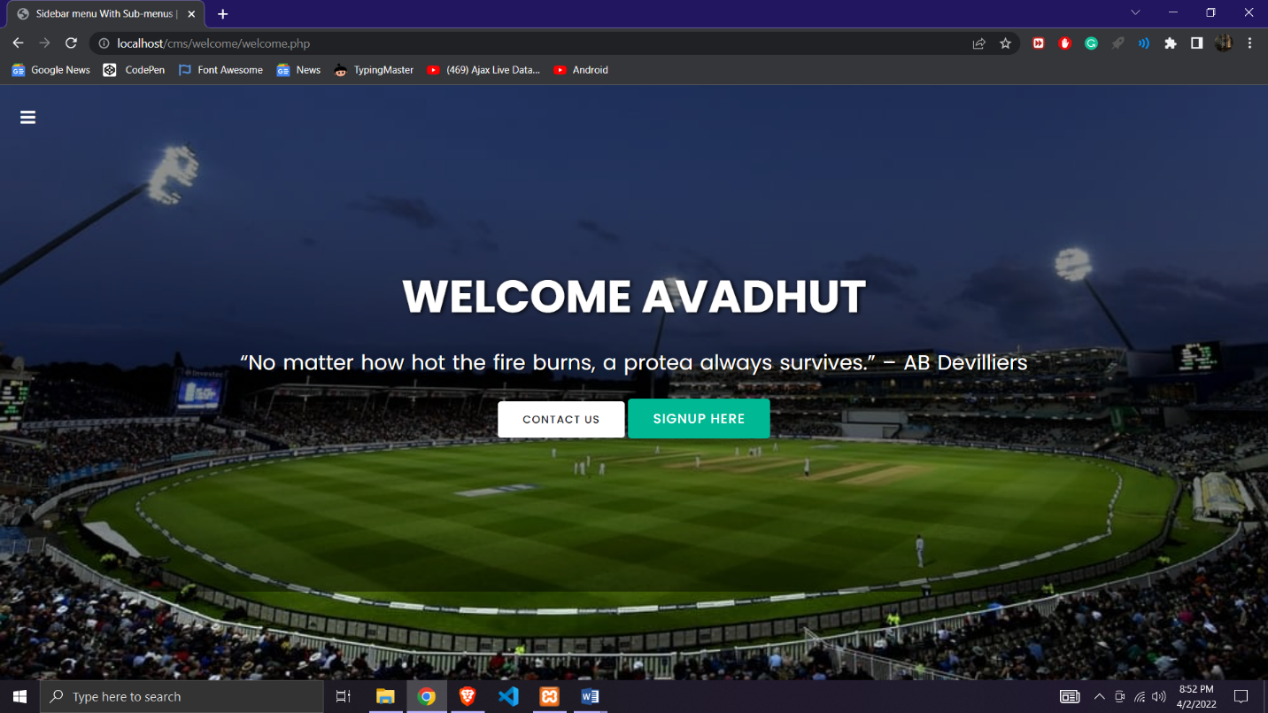

**REGISTRATION PAGE**

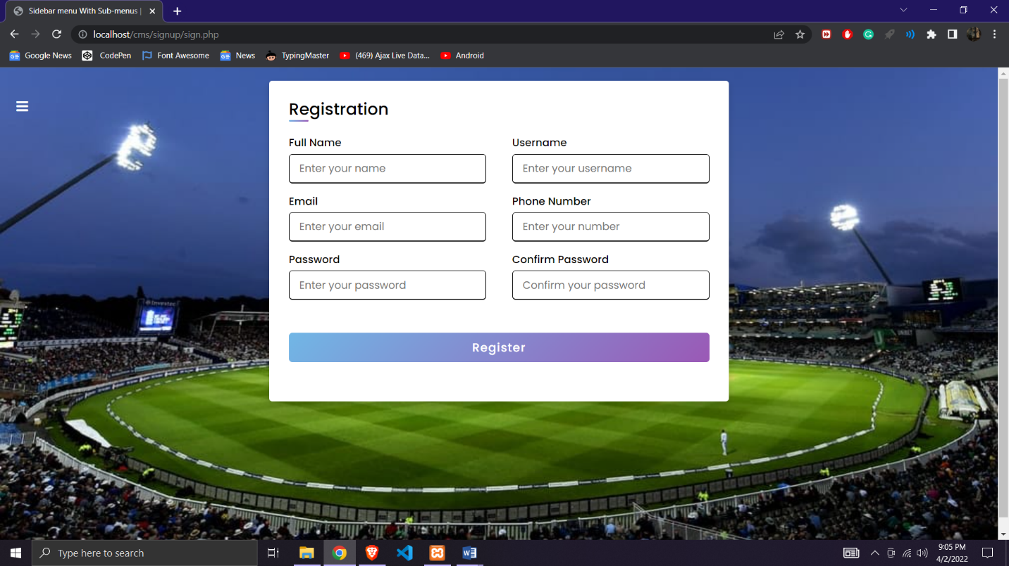

**LOGIN PAGE**

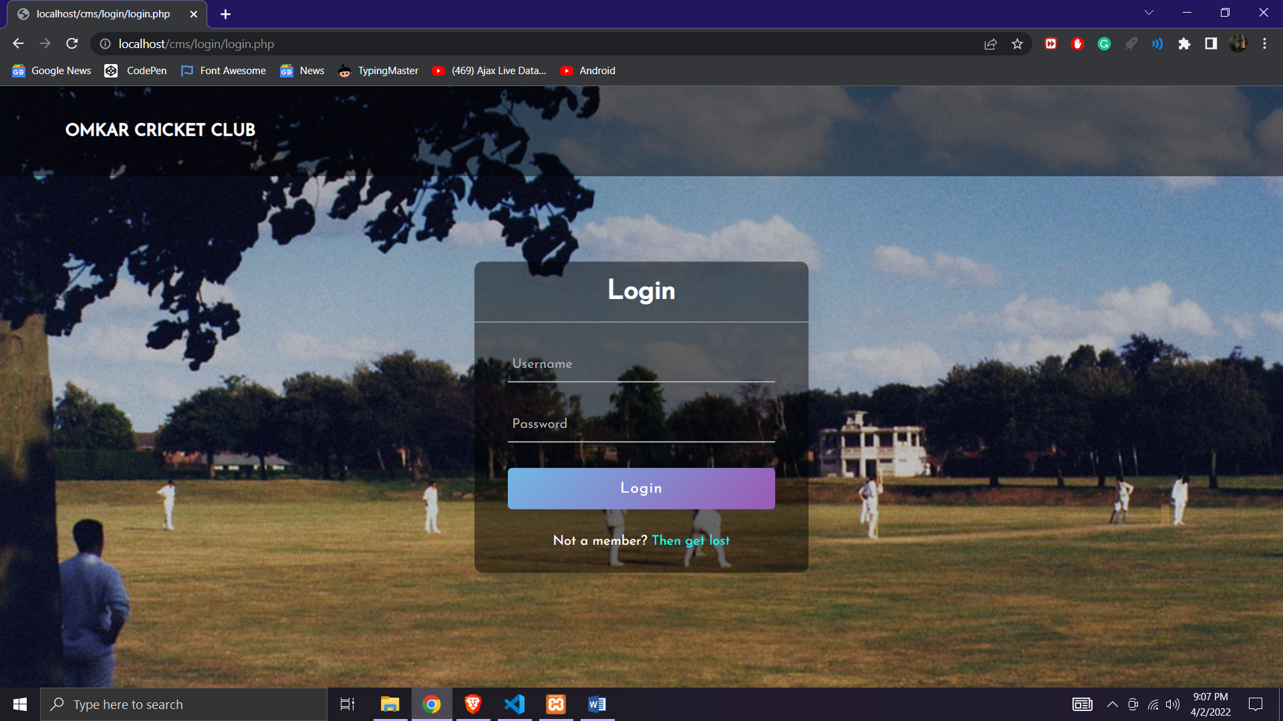

**MODULES PAGE**

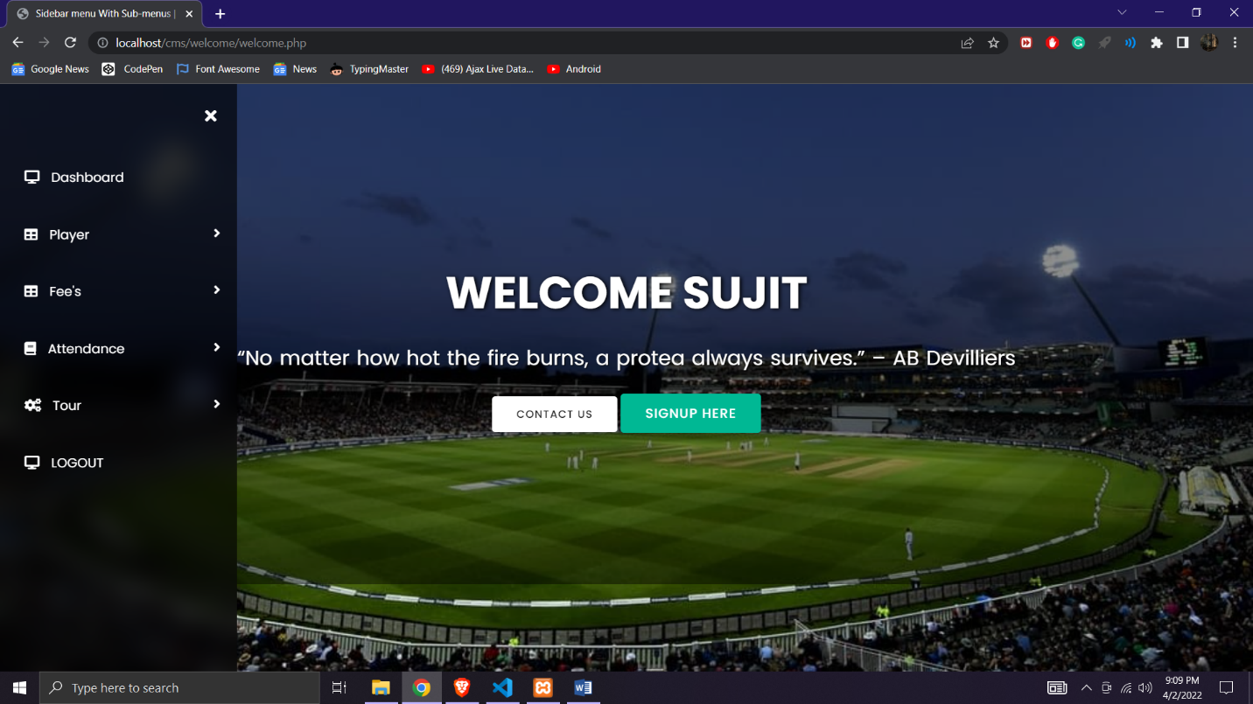

**ADD PLAYER PAGE**

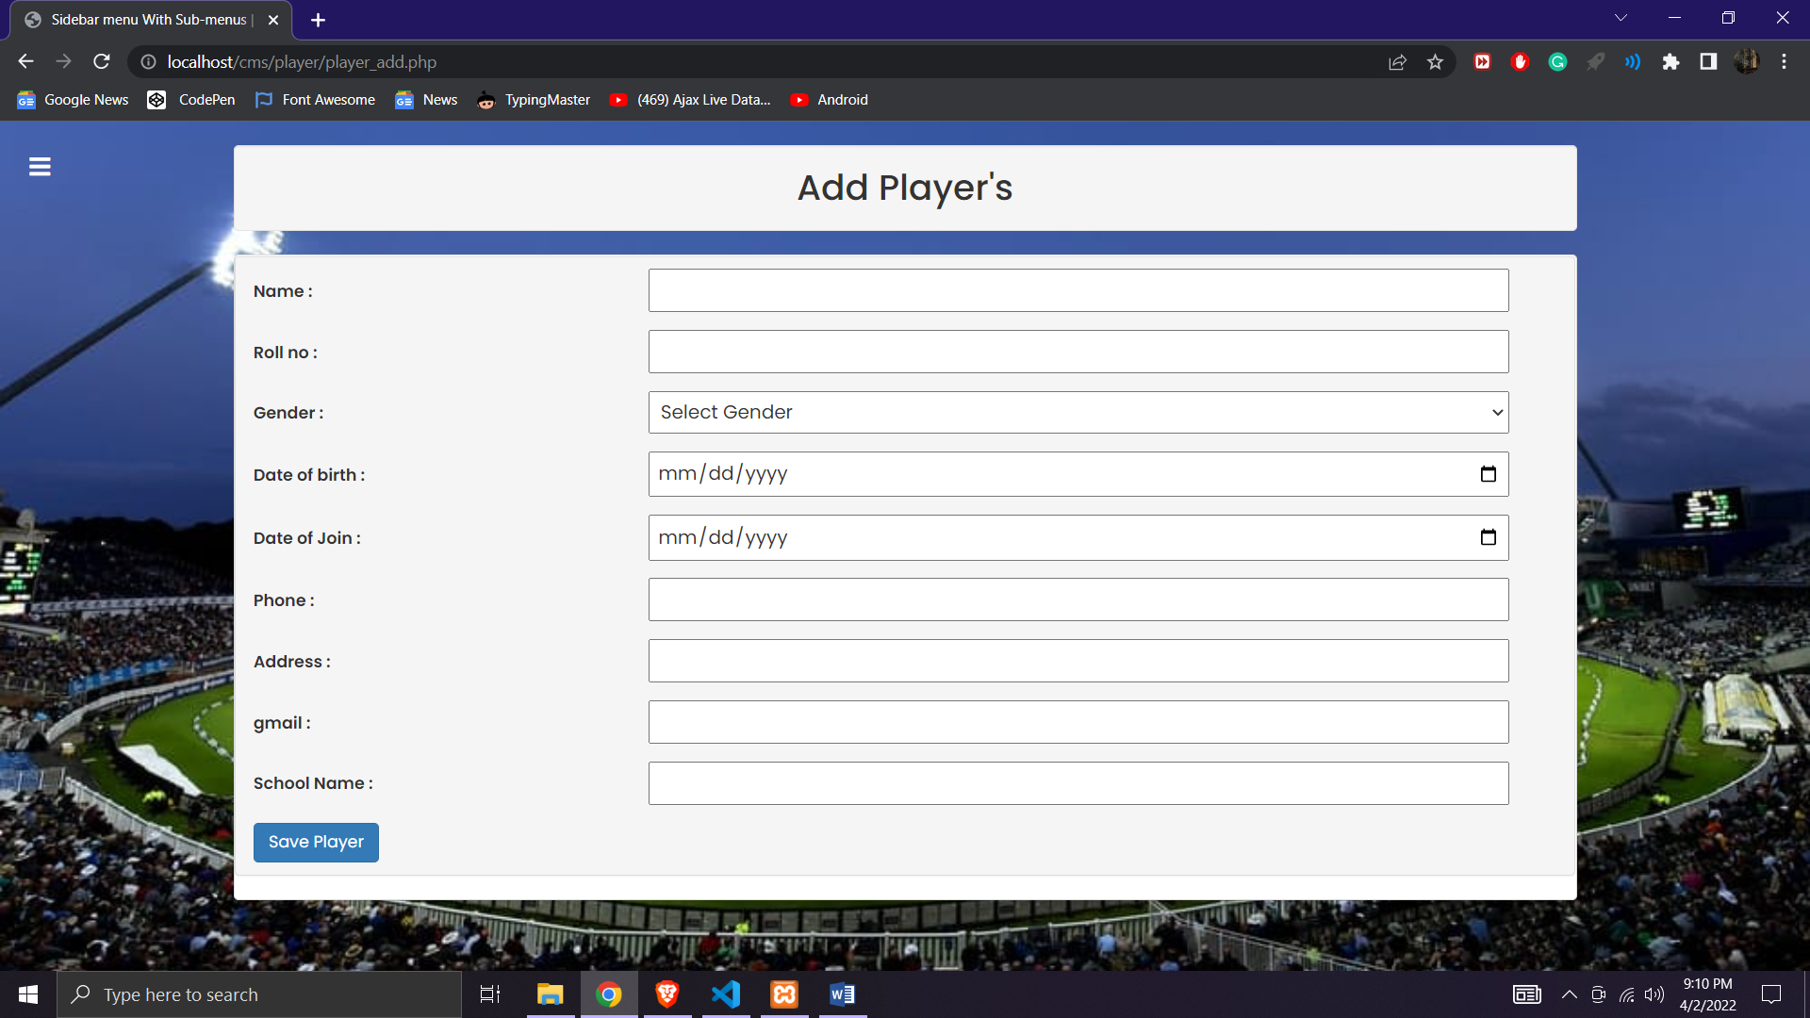

**VIEW PLAYER PAGE**

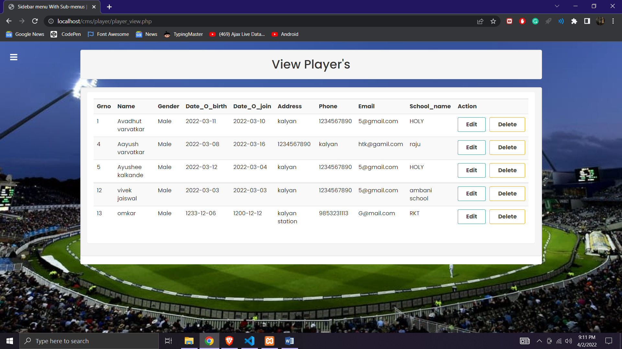

**UPDATE PLAYER PAGE**

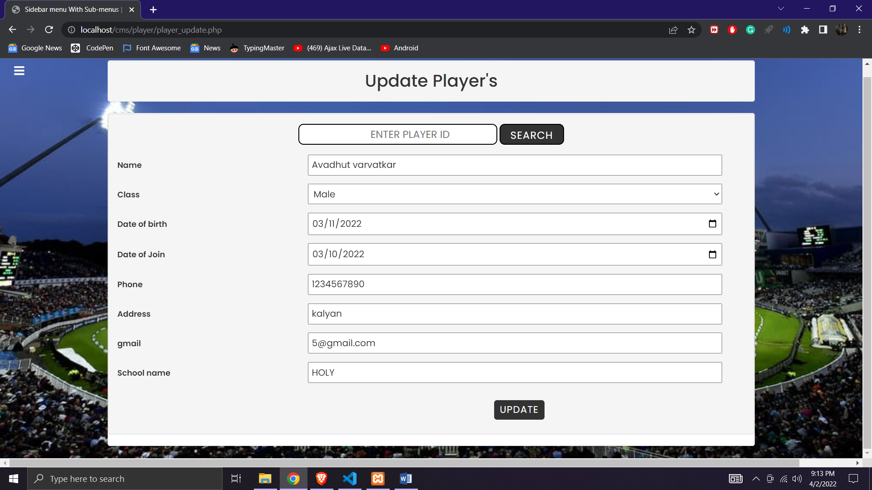

**DELETE PLAYER PAGE**

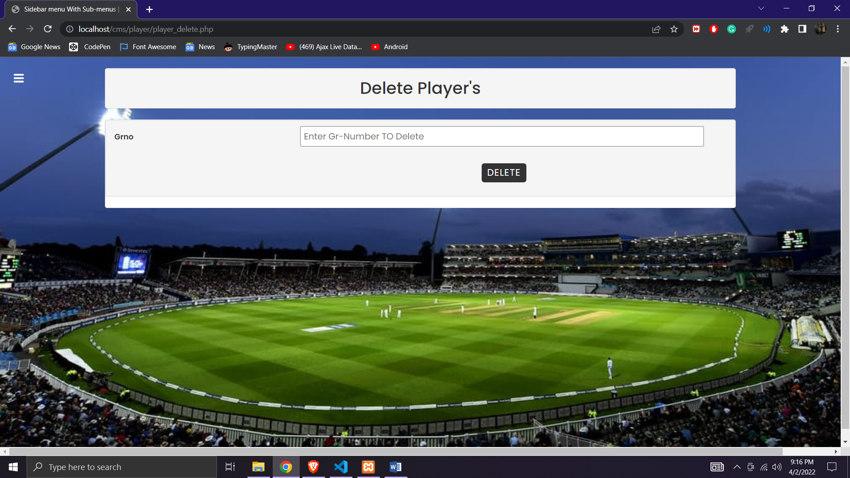

**ADD ATTENDANCE PAGE**

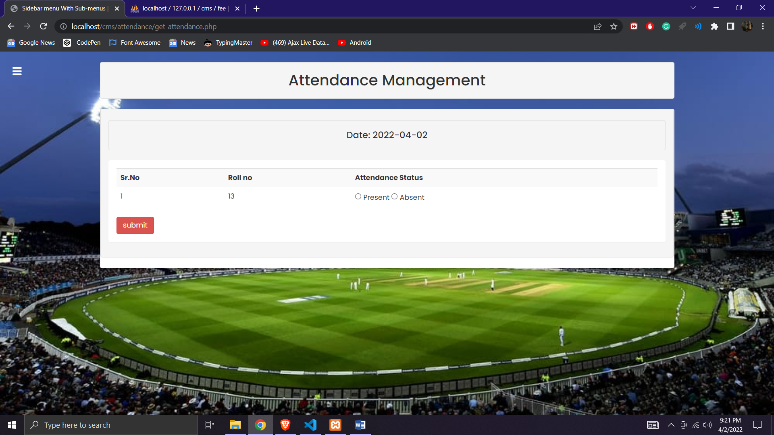

**VIEW RECORDS PAGE**

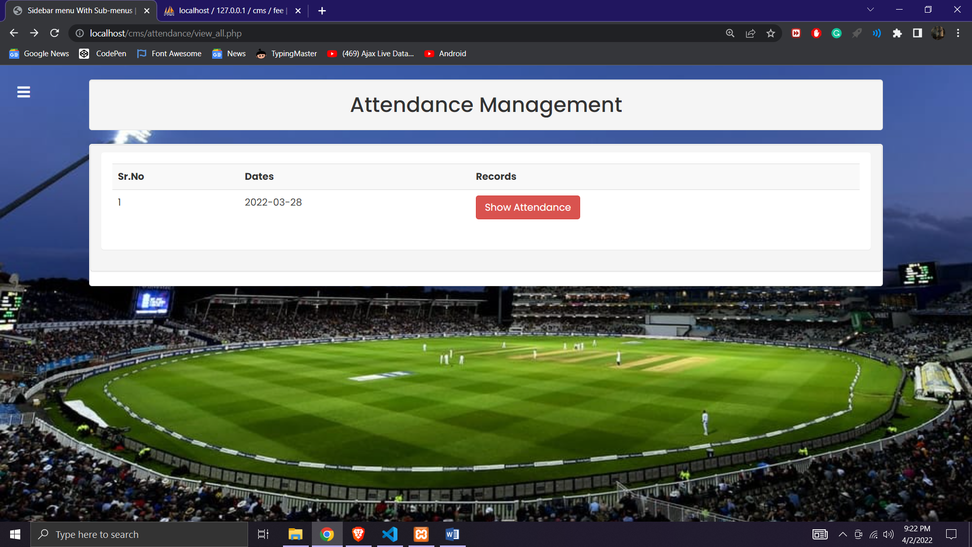

**VIEW ATTENDANCE PAGE**

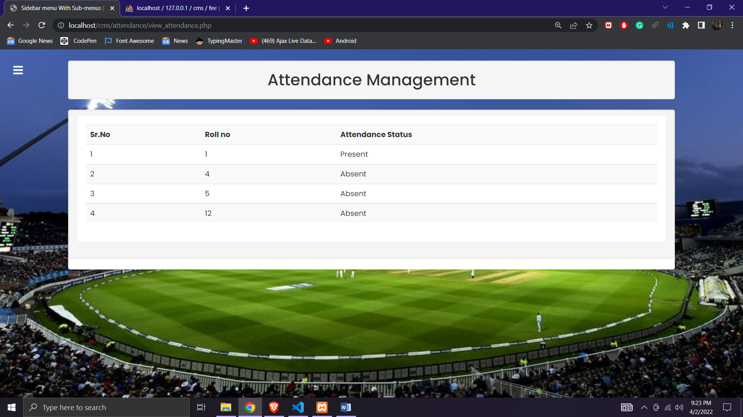

**ADD TOUR PAGE**

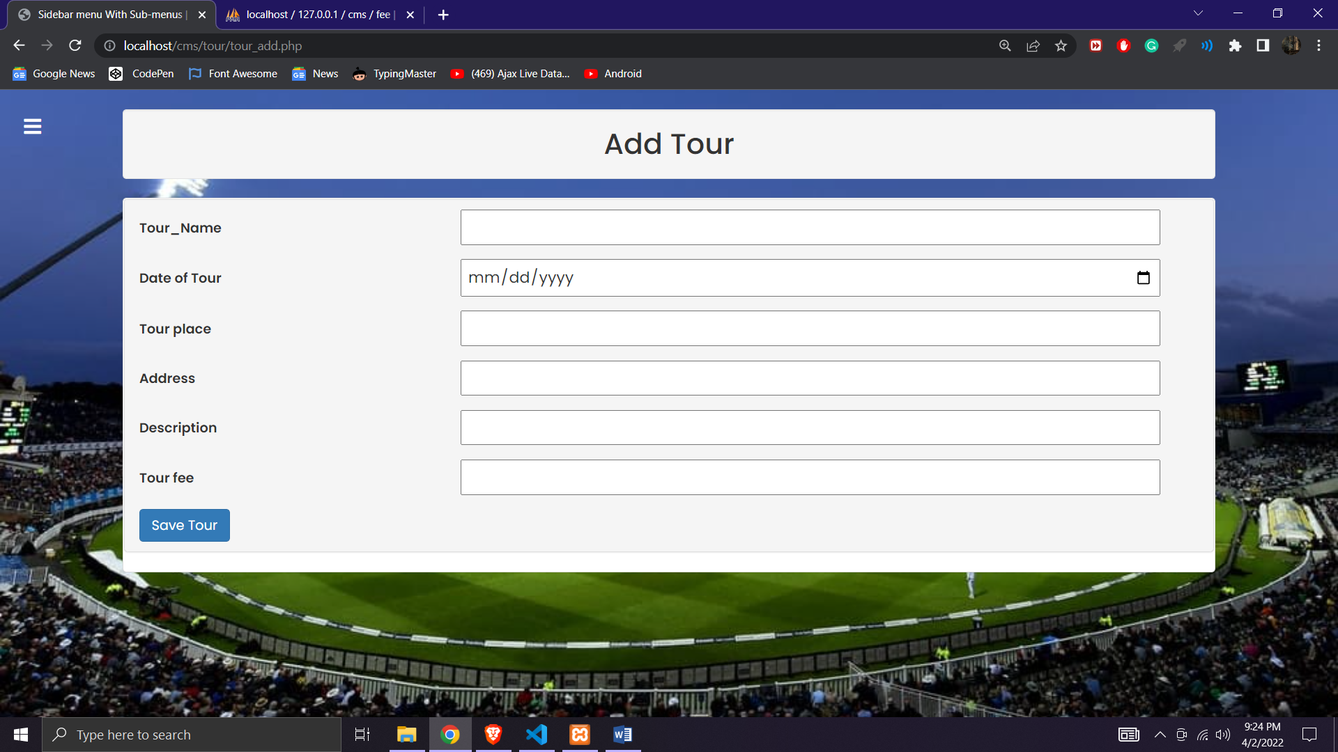

**VIEW TOUR PAGE**

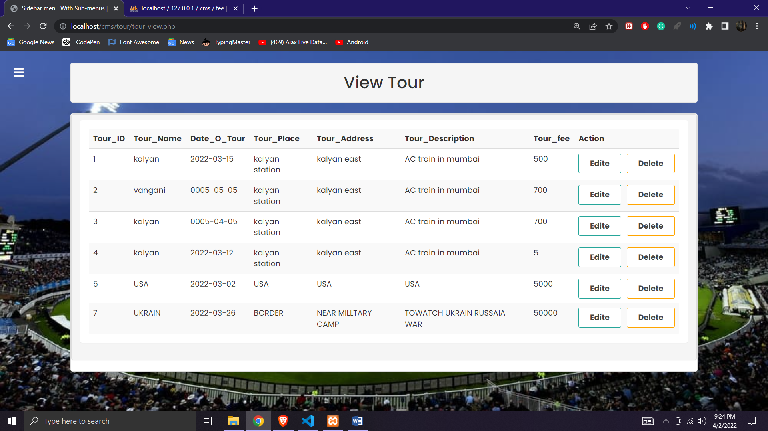

**SEARCH TOUR PAGE**

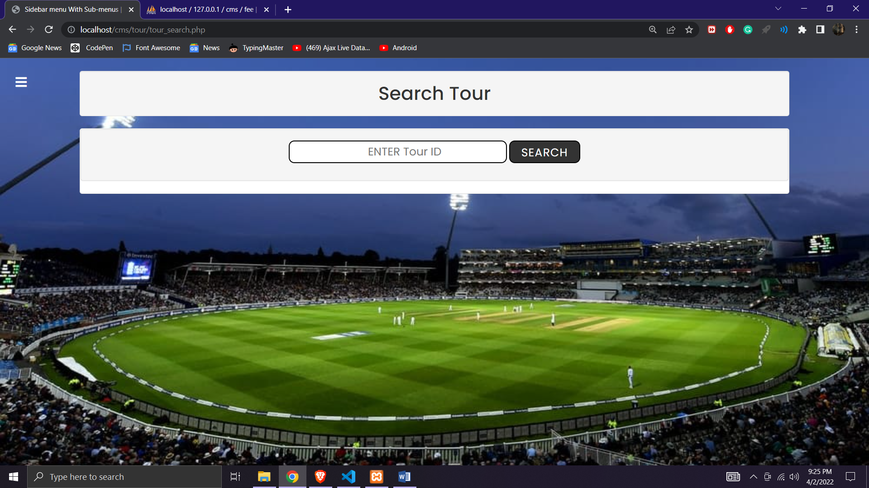

**ADD FEE PAGE**

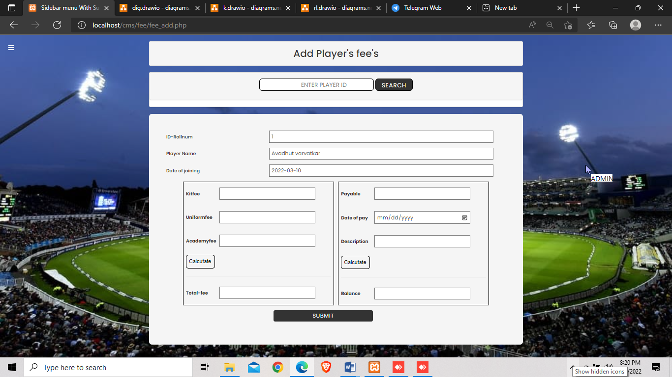

**VIEW PAGE**

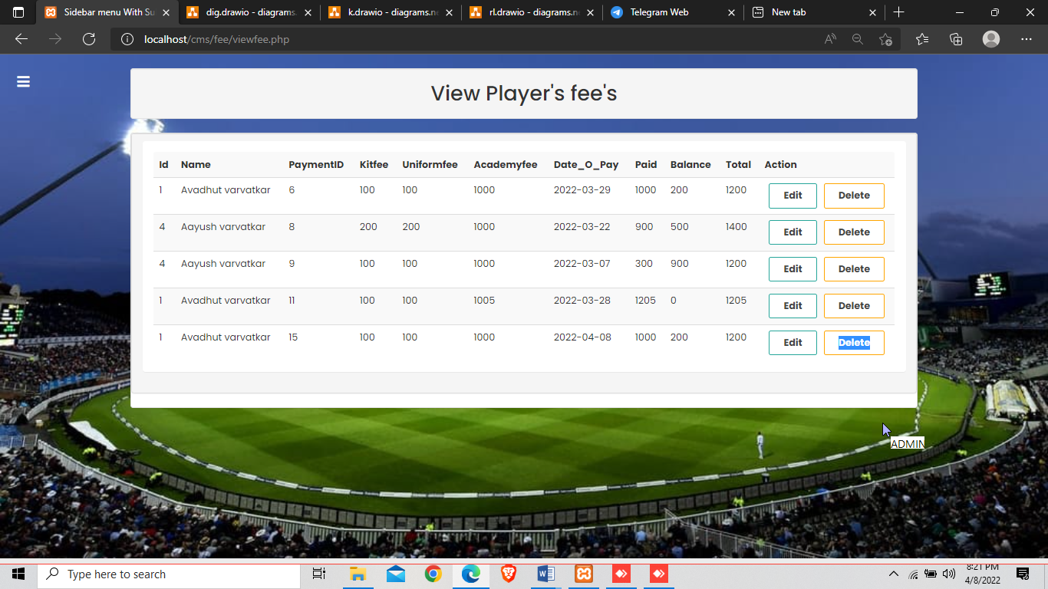

**FEES’S TABLE PAGE**

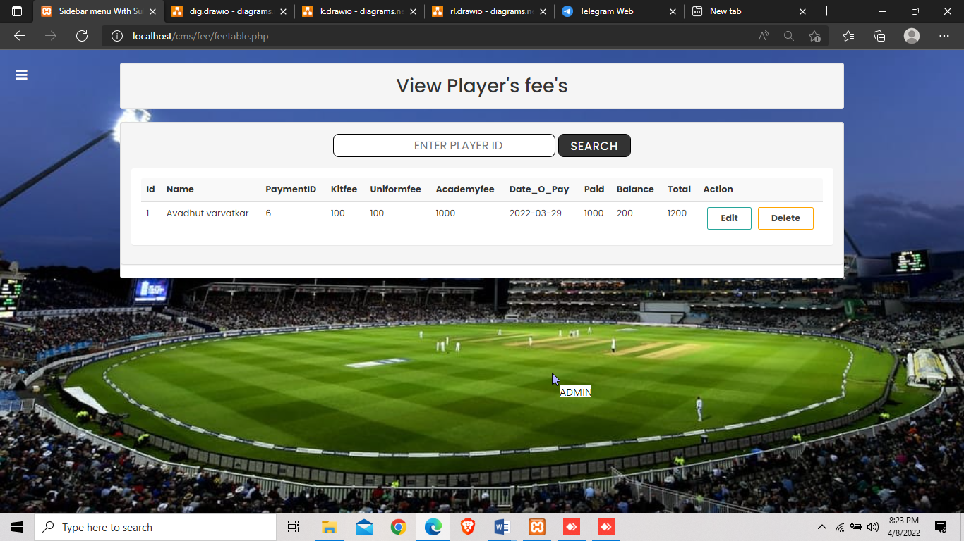

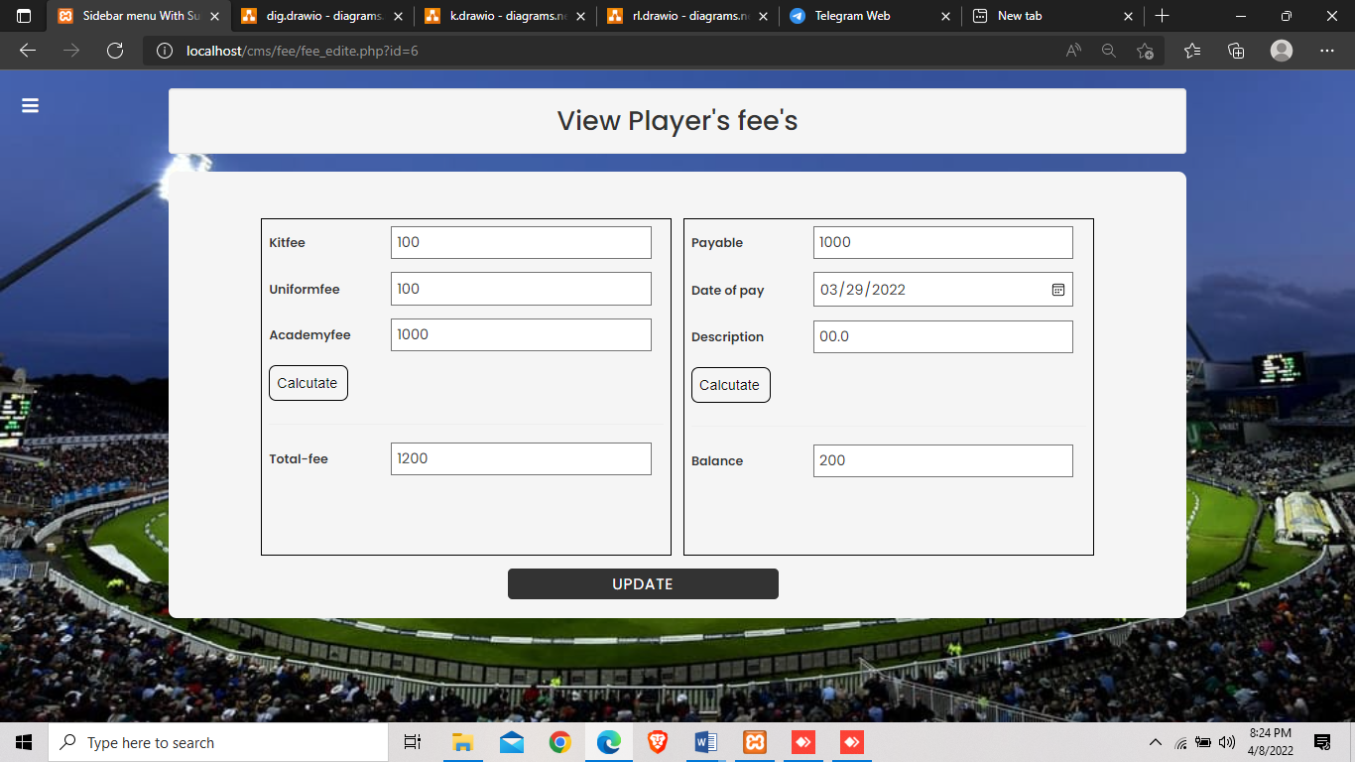

**CONTACT PAGE**

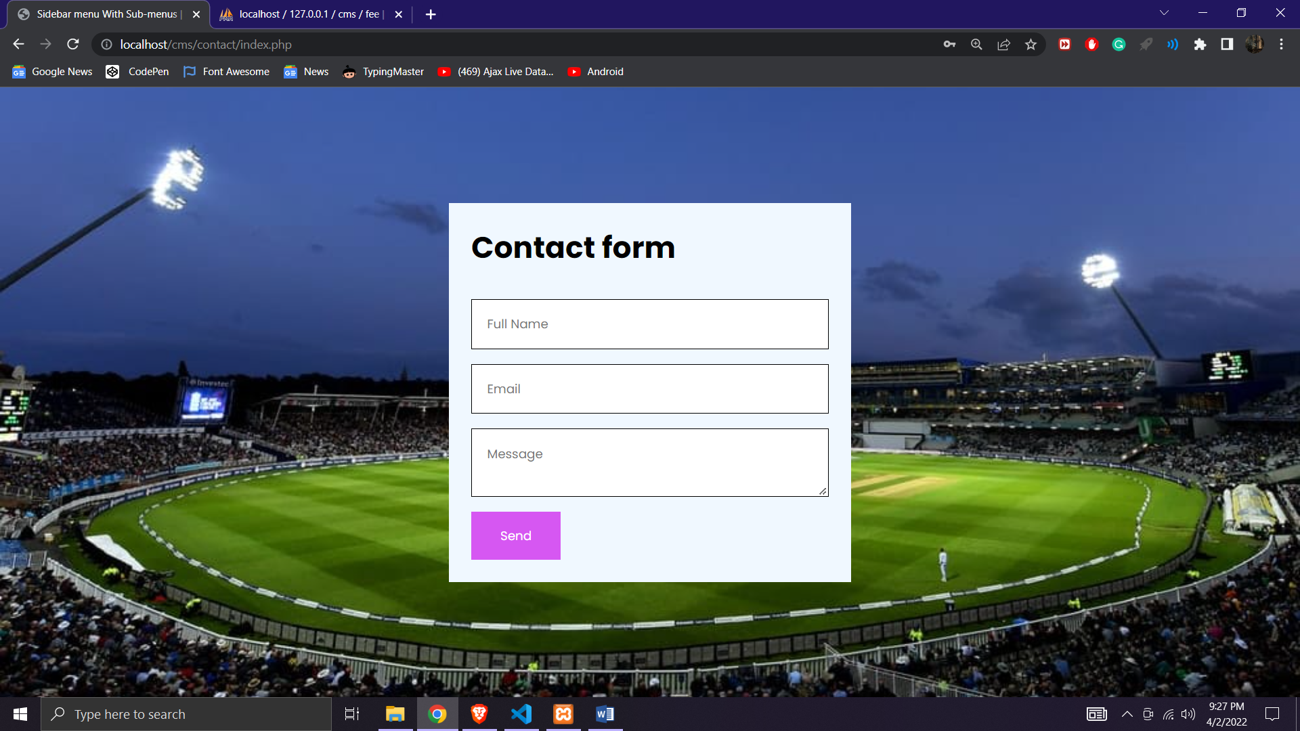

CONCLUSION

**CONCLUSION:-**

The system has been tested under all criteria. All phases of development were conceived using methodologies. The application executes successfully by fulfilling the objectives of the project. Further extensions to this system can be made required with minor modifications.

**SYSTEM IMPLEMENTAION**

Security implementation is very important in almost every software project.

In this project, user authentication is placed, when the application run, a login screen will be displayed where user needs to enter his credentials to gain access to the system.

In this system there is login access for only authenticated persons only, like admin. This user has complete access to the system.

FUTURE ENHANCEMENT

The Current System can include many more enhancements. These are as Follows:

Buy from the card is the optional in this project.

There is no verification while buy from the card.

The Payment Gateway is not added in this project.

As mentioned earlier, the project is web based application. This will convert into

Android application which will enhance the project.

Hence, the current software would be updated in near future to overcome limitation as specified above.